Joel Cabrera

Economic Forecasting and Big Data (01:220:423)

Professor Berisha

October 21, 2019

**Using your data from project 1, please answer the following questions.**

The two variables that I have used for project 1 and am continuing to use for project 2 are as follows: the Labor Force Participation Rate in New Jersey (NJ) since 1976 and the Unemployment Rate in New Jersey (NJ) since 1976. They both collectively have 524 observations and are based on monthly frequencies (starting and ending on January 1976 and August 2019, respectively). The datasets that contain these two variables, which are coded in R and hereafter referred to as LFPR and UR, respectively, can be found from these two websites, also respectively: <https://fred.stlouisfed.org/series/LBSSA34> and <https://fred.stlouisfed.org/series/NJURN>. For the purposes of this assignment, these two datasets have been combined into one; the variables are still named LFPR and UR, of course.

1. **Plot the time series and identify seasonal fluctuations and/or a trend-cycle?**

Below are graphs that illustrate the variables in a specific time-series fashion. Graphs 1a and 1c depict simple time plots of the LFPR and UR variables (they are only used for being juxtaposed with Graphs 1b and 1d, respectively). Graphs 1b and 1d depict not only the values of LFPR and UR variables in certain time periods, but also estimate their trend-cycles via a moving average of order 4 (4-MA), respectively. In other words, each graph contains a variable’s time plot and 4-MA estimated trend-cycle.

Graph 1a:

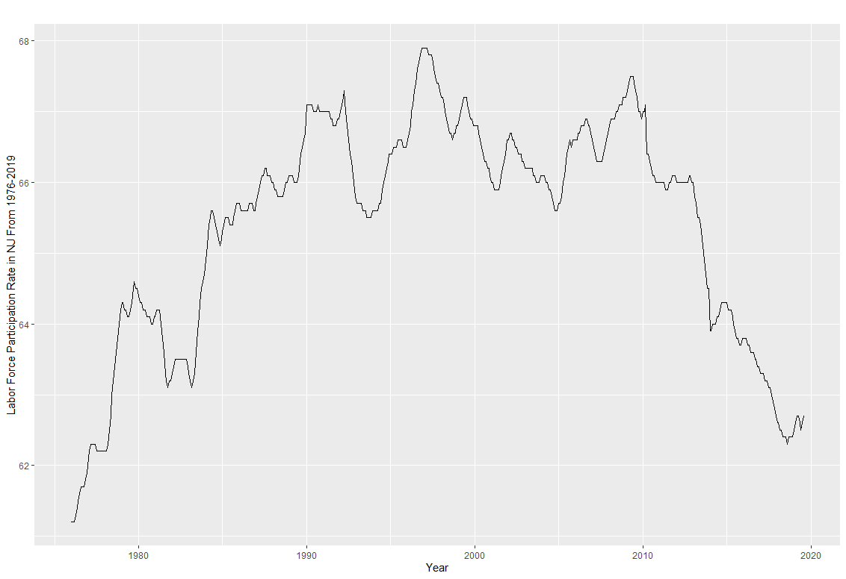

Graph 1b:

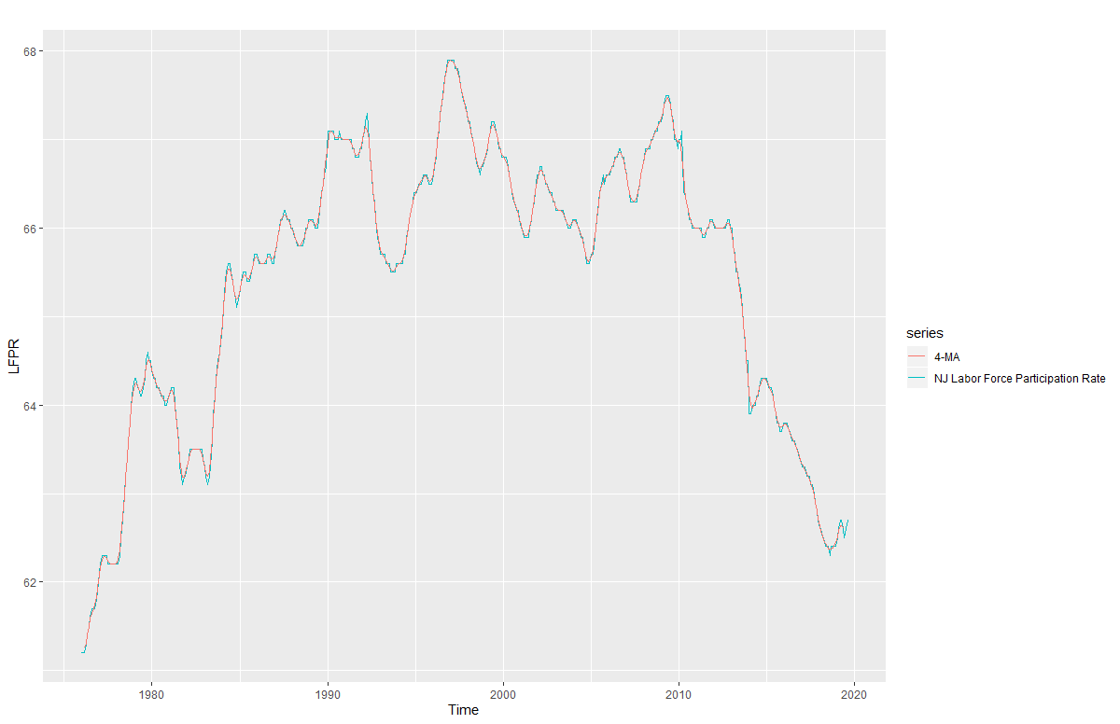

Examining Graph 1b, we see that the actual series, the NJ Labor Force Participation Rate (LFPR) has many visible seasonal fluctuations. We can also see that the long-term trend cycle, 4-MA – which removes seasonality in said series, seems to be consistent with some of the peaks and troughs of the actual series (as well as many other points, generally speaking). It seems to have an initial upward trend, and then a downward trend. An example of the trend-cycle would be that, in 1980, the LFPR is at around 64.5%; however, because it is above the trend-cycle, it is expected to decline in the next year. Another example of this would be that, in around 1999, the LFPR is at around 67.2%; however, because it is above the trend-cycle, it is expected to decline in the next year. One more example of this would be that, in around 2014, the LFPR is at around 64%; however, because it is below the trend-cycle, it is expected to rise in the next year.

Graph 1c:

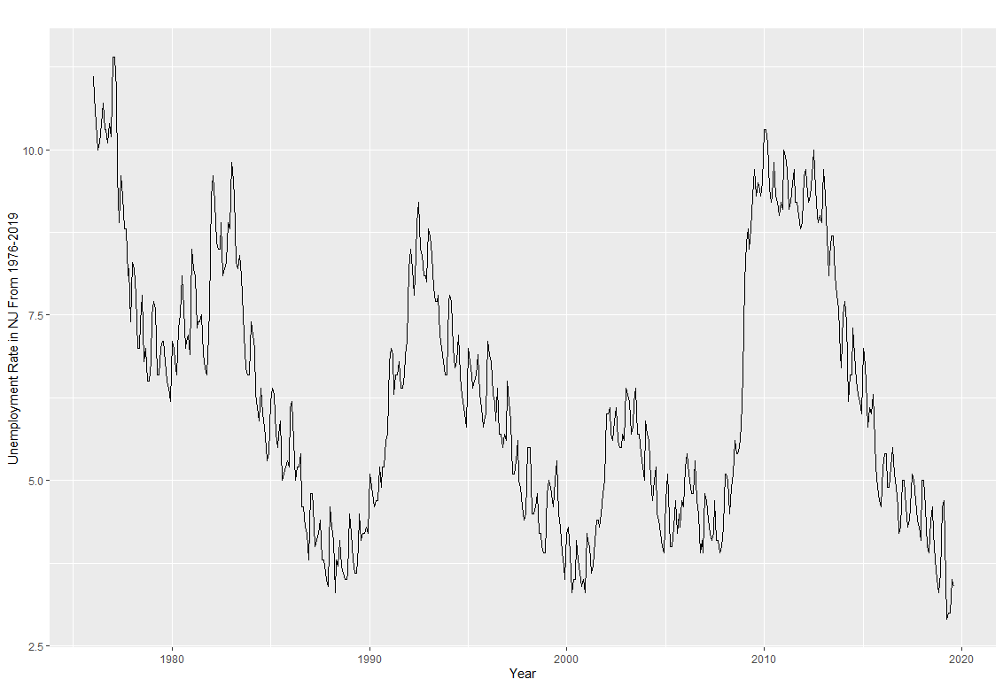

Graph 1d:

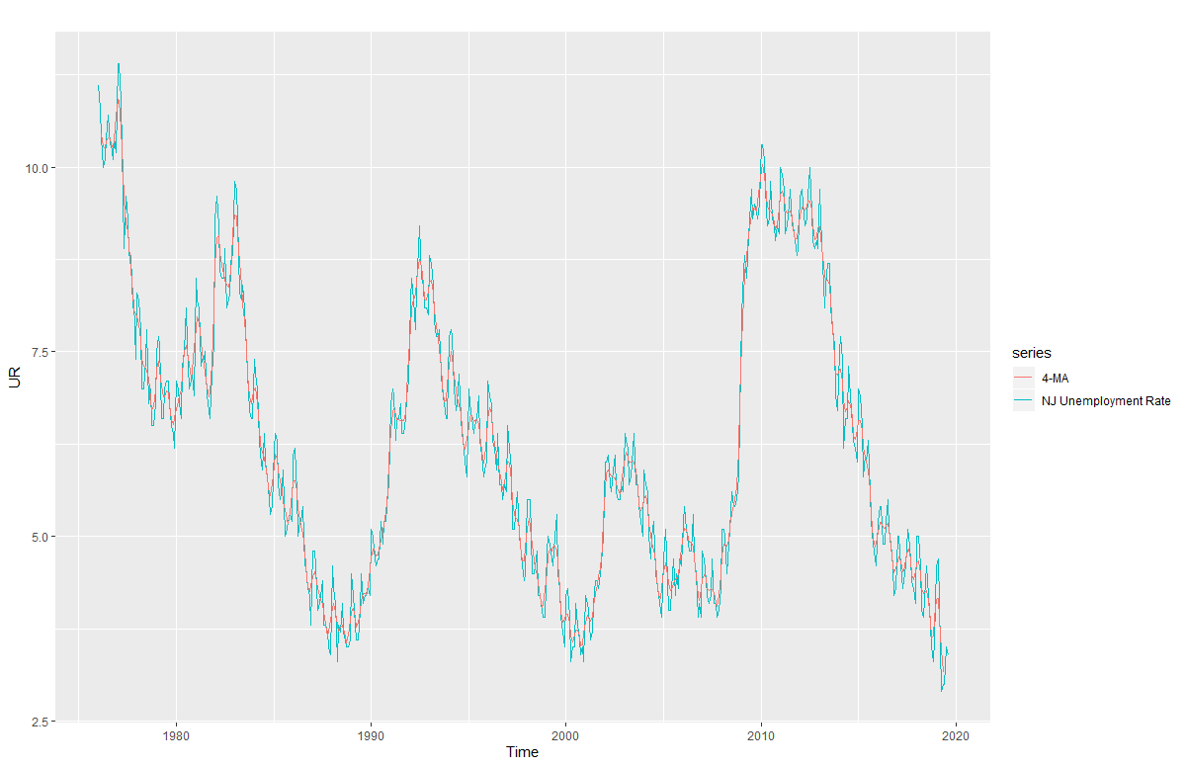

Examining Graph 1d, we see that the actual series, the NJ Unemployment Rate (UR) has many visible seasonal fluctuations. We can also see that the long-term trend cycle, 4-MA – which removes seasonality in said series, seems to be consistent with many of the peaks and troughs of the actual series (as well as many other points, generally speaking). It does seem to have a singular type of trend, however; it has many “ups” and “downs”. An example of the trend-cycle would be that, in 1980, the UR is at 6.25%; however, because it is below the trend-cycle, it is expected to rise in the next year. Another example of this would be that, in 2000, the UR is at around 3.90%; however, because it is above the trend-cycle, it is expected to decline in the next year. One more example of this would be that, in around 2015, the UR is at around 7%; however, because it is above the trend-cycle, it is expected to decline in the next year.

1. **Use a classical multiplicative decomposition and a classical additive decomposition to calculate the trend-cycle, seasonal indices, and the remainder. Do the results support the graphical interpretation from part a? Please explain what does the seasonal component indicate?**

Below are graphs that illustrate the classical additive and classical multiplicative decompositions of the LFPR and NJ variables - each containing four more graphs, which correspond to the seasonal, trend, and remainder components, respectively.

Graphs 2a and 2b depict the additive and multiplicative decompositions of LFPR, whereas Graphs 2c and 2d depict the additive and multiplicative decompositions of UR.

Graphs 2a:

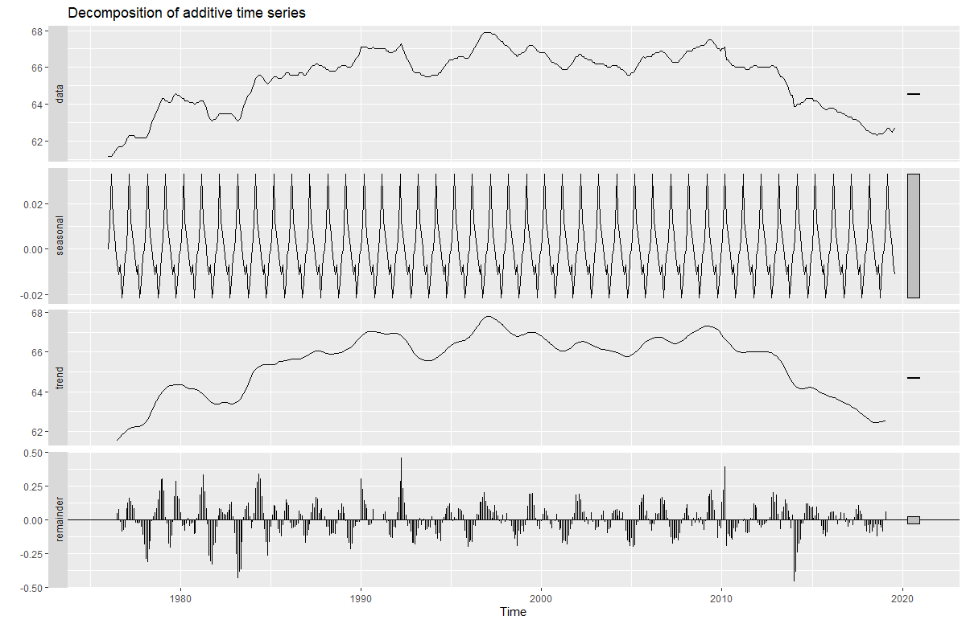

Examining Graph 2a, when additively decomposed, we see that the actual series of the LFPR variable seems to be consistent with the graphical results of the seasonal, trend, and remainder components. Whenever the data increases or decreases, the trend also increases or decreases. Also, the data’s increases and decreases seem to be of a known and fixed frequency, as its seasonal component would indicate. Lastly, the data’s remainder component seems to be able to capture the residuals resulting from changes in said data.

Graphs 2b:

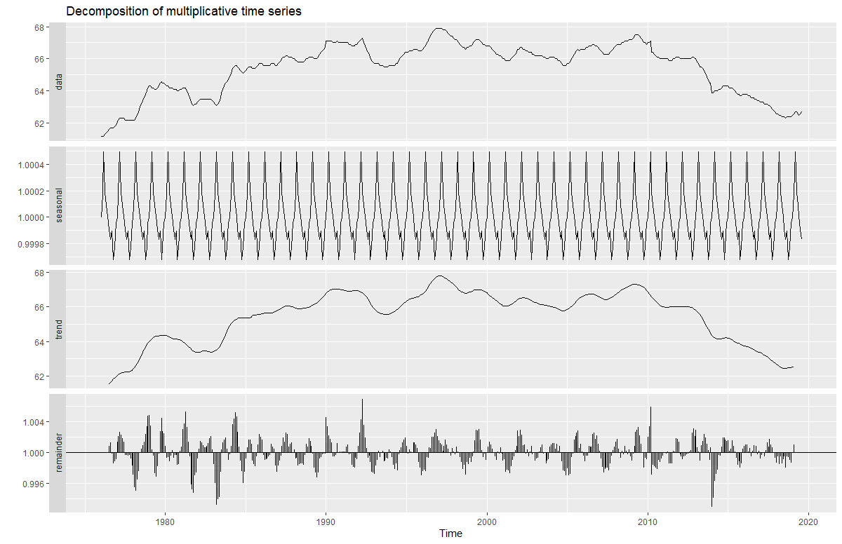

Examining Graph 2b, when multiplicatively decomposed, we see that the actual series of the LFPR variable seems to be consistent with the graphical results of the seasonal, trend, and remainder components. Whenever the data increases or decreases, the trend also increases or decreases. Also, the data’s increases and decreases seem to be of a known and fixed frequency, as its seasonal component would indicate. Lastly, the data’s remainder component seems to be able to capture the residuals resulting from changes in said data.

Graphs 2c:

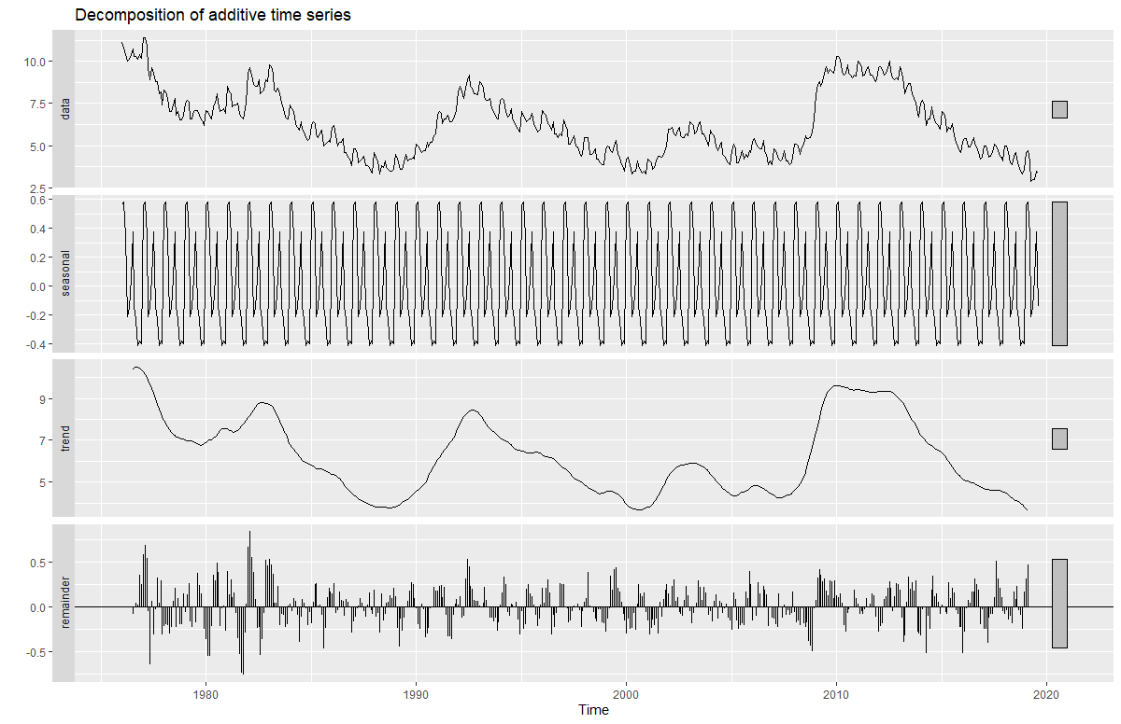

Examining Graph 2c, when additively decomposed, we see that the actual series of the UR variable seems to be consistent with the graphical results of the seasonal, trend, and remainder components. Whenever the data increases or decreases, the trend also increases or decreases. Also, the data’s increases and decreases seem to be of a known and fixed frequency, as its seasonal component would indicate. Lastly, the data’s remainder component seems to be able to capture the residuals resulting from changes in said data. (However, this finding is contradicted by an examination of the seasonal indices on UR; it is explained in the penultimate paragraph).

Graphs 2d:

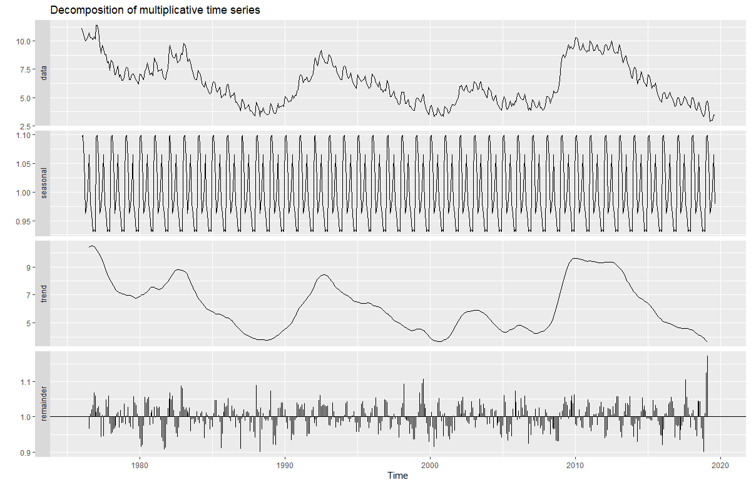

Examining Graph 2d, when multiplicatively decomposed, we see that the actual series of the UR variable seems to be consistent with the graphical results of the seasonal, trend, and remainder components. Whenever the data increases or decreases, the trend also increases or decreases. Also, the data’s increases and decreases seem to be of a known and fixed frequency, as its seasonal component would indicate. Lastly, the data’s remainder component seems to be able to capture the residuals resulting from changes in said data. (However, this finding is contradicted by an examination of the seasonal indices on UR; it is explained in the penultimate paragraph).

To further our analyses of the actual data relative to their components, we shall now explain what the seasonal component means for each type of decomposition, and what implications it has for said data.

For additive decomposition, if the seasonal component is 0, then there is no seasonality. If the seasonal component is less than (<) 0, then the actual series will be below the trend-cycle. If the seasonal component is greater than (>) 0, then the actual series will be above the trend-cycle.

For multiplicative decomposition, if the seasonal component is 1, then there is no seasonality. If the seasonal component is less than (<) 1, then the actual series will be below the trend-cycle. If the seasonal component is greater than (>) 1, then the actual series will be above the trend-cycle.

Applying these ideas into the additive and multiplicative decompositions of LFPR, based upon an examination of their respective seasonal indices (see Appendices 2b and 2e), we can see that they are consistent with the interpretation made previously. Using the first example made previously: For additive decomposition, in 1980, the seasonal indices on July to December are all negative, indicating that the actual series is expected to be below the trend-cycle next year. For multiplicative composition, in 1980, the seasonal indices on July to December are < 1, indicating that the actual series is expected to be below the trend-cycle next year.

Applying these ideas into the additive and multiplicative decompositions UR, based upon an examination of their respective seasonal indices (see Appendices 3b and 3e), we can see that they are not consistent with the interpretation made previously. Using the first example made previously: For additive decomposition, in 1980, the seasonal indices on August to December are all negative, indicating that the actual series is expected to be below the trend-cycle next year (which is not the case; graphically, it is expected to rise instead). For multiplicative composition, in 1980, the seasonal indices on August to December are < 1, indicating that the actual series is expected to be below the trend-cycle next year (which, again, is not the case; graphically, it is expected to rise instead).

Based on the graphical and statistical results above, as well as the calculated values of the trend-cycle, seasonal, and remainder components (which can be found in Appendices 2a-2f and 3a-3f for LFPR and UR, respectively): We can assert that the additive and multiplicative decompositions of LFPR support the graphical interpretation made for the two-part time plot for LFPR in the previous question. However, we can also assert that the additive and multiplicative decompositions of UR do not support the graphical interpretation made for the two-part time plot for UR in the previous question.

1. **Please identify if your series are multiplicative or additive decomposed. Show all your steps you have taken to make the decision.**

Below are graphs and R output that indicate the autocorrelation function (ACF) of and Box-Pierce tests, respectively, for the remainder component of the classical additive and classical multiplicative decompositions for the LFPR and UR variables.

Graph 3a and Output 2a indicate the ACF and Box-Pierce test of the remainder component of the additive decomposition of LFPR.

Graph 3b and Output 2b indicate the ACF and Box-Pierce test of the remainder component of the multiplicative decomposition of LFPR.

Graph 3c and Output 2c indicate the ACF and Box-Pierce test of the remainder component of the additive decomposition of UR.

Graph 3d and Output 2d indicate the ACF and Box-Pierce test of the remainder component of the multiplicative decomposition of UR.

Graph 3a:

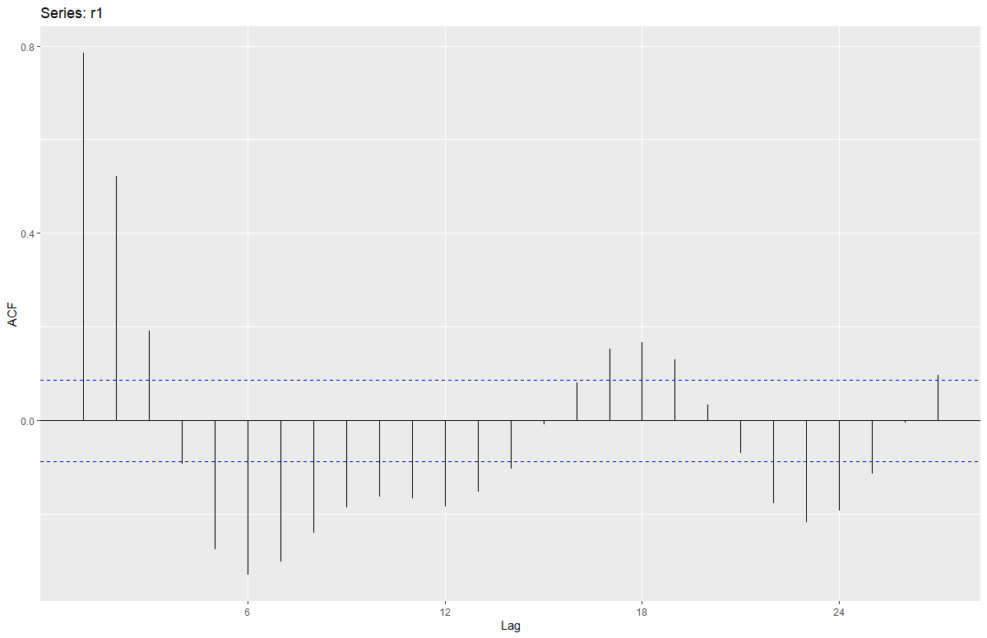

Output 2a:

Box-Pierce test

data: r1

X-squared = 315.76, df = 1, p-value < 2.2e-16

Examining Graph3a and Output2a, we see that the remainder of the additive decomposition of LFPR has its lags consistently pass the upper and lower blue significance thresholds, and that the its p-value is less than 0.05. Because of this, we can say that the remainder is statistically significant at the 5% level, and that we reject the H0 – that the remainder is not serially correlated. Such a finding implies that the remainder is, indeed, serially correlated, and thus, LFPR is not additively decomposed.

Graph 3b:

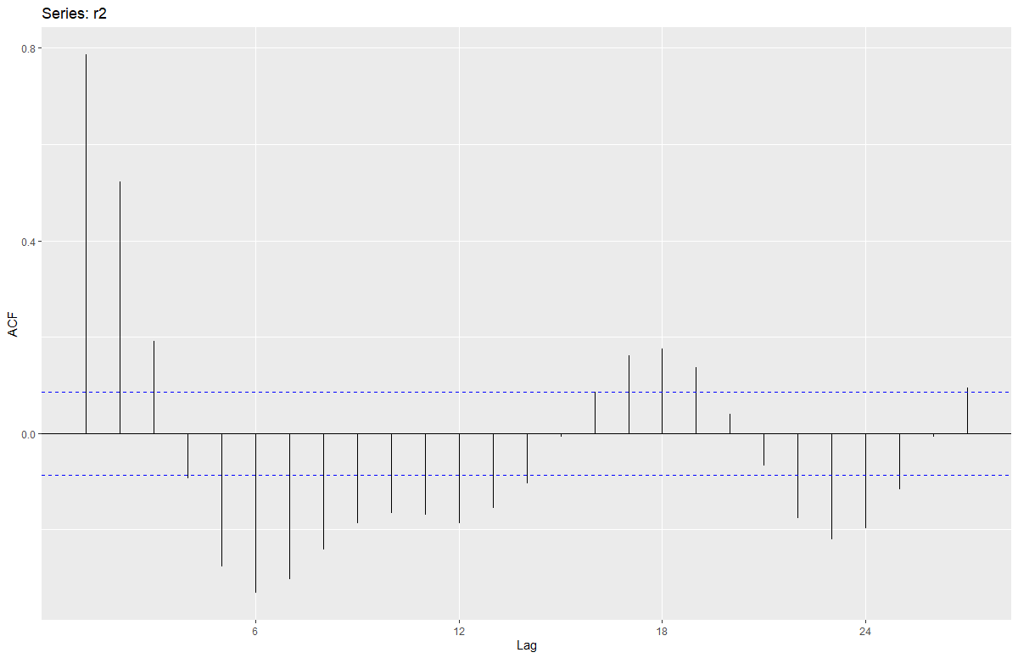

Output 2b:

Box-Pierce test

data: r2

X-squared = 316.84, df = 1, p-value < 2.2e-16

Examining Graph3b and Output2b, we see that the remainder of the multiplicative decomposition of LFPR has its lags consistently pass the upper and lower blue significance thresholds, and that the its p-value is less than 0.05. Because of this, we can say that the remainder is statistically significant at the 5% level, and that we reject the H0 – that the remainder is not serially correlated. Such a finding implies that the remainder is, indeed, serially correlated, and thus, LFPR is also not multiplicatively decomposed.

Graph 3c:

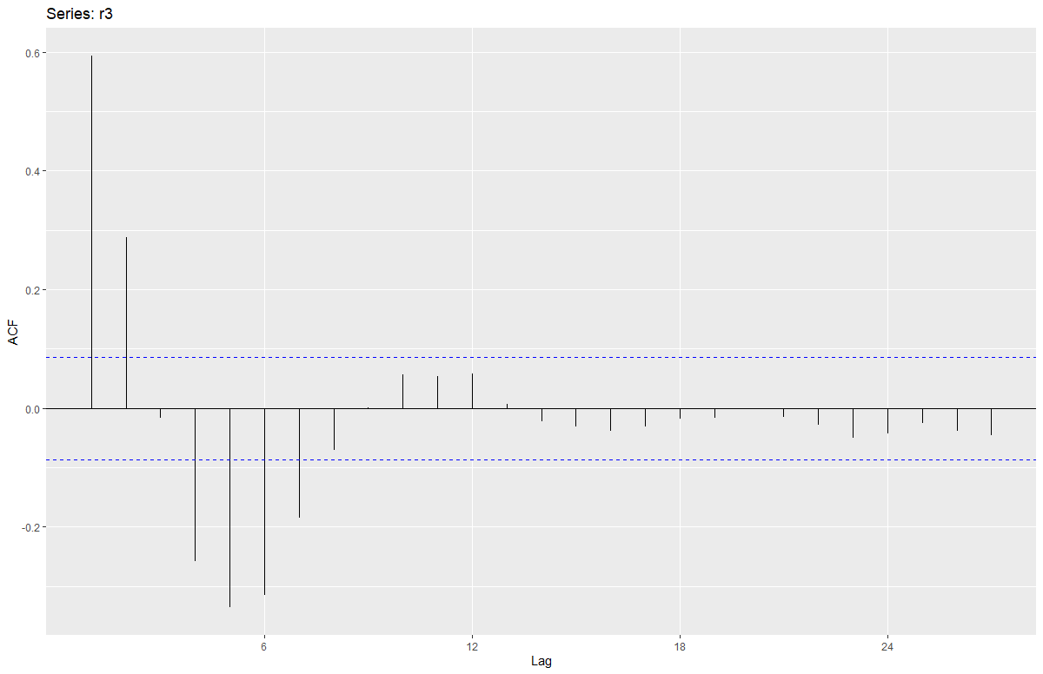

Output 2c:

Box-Pierce test

data: r3

X-squared = 180.68, df = 1, p-value < 2.2e-16

Examining Graph3c and Output2c, we see that the remainder of the additive decomposition of UR has some of its lags initially pass the upper and lower blue significance thresholds, and that the its p-value is less than 0.05. Because of this, we can say that the remainder is statistically significant at the 5% level, and that we reject the H0 – that the remainder is not serially correlated. Such a finding implies that the remainder is, indeed, serially correlated, and thus, UR is not additively decomposed.

Graph 3d:

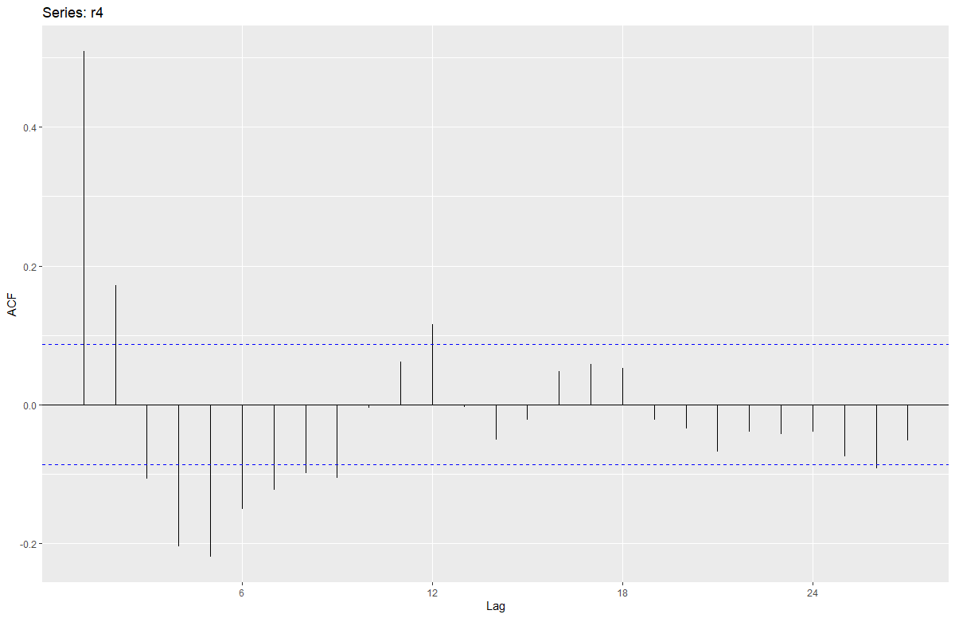

Output 2d:

Box-Pierce test

data: r4

X-squared = 132.94, df = 1, p-value < 2.2e-16

Examining Graph3d and Output2d, we see that the remainder of the multiplicative decomposition of UR has some of its lags initially pass the upper and lower blue significance thresholds, and that the its p-value is less than 0.05. Because of this, we can say that the remainder is statistically significant at the 5% level, and that we reject the H0 – that the remainder is not serially correlated. Such a finding implies that the remainder is, indeed, serially correlated, and thus, UR is also not multiplicatively decomposed.

Based on all of the statistical results and their corresponding interpretations above, it can be concluded that the LFPR variable is neither additively or multiplicatively decomposed, and that the UR variable is also neither additively or multiplicatively decomposed. Further investigation and more advanced econometric techniques, then, are required to determine the type of decomposition each variable has.

**Appendix A – R Code**

# Joel Cabrera

# Economic Forecasting and Big Data (01:220:423)

# Professor Berisha

# October 21, 2019

#Loading data

data=read.csv(file.choose(), header=TRUE)

summary(data)

#libraries MUST BE RAN FIRST

library(TSA)

library(dplyr)

library(ggplot2)

library(forecast)

library(tseries)

#variables becoming time series

#1

LFPR=ts(data$LBSSA34, frequency=12, start = c(1976,1))

UR=ts(data$NJURN, frequency=12, start = c(1976,1))

autoplot(LFPR)+xlab("Year") + ylab("Labor Force Participation Rate in NJ From 1976-2019")

autoplot(UR)+xlab("Year") + ylab("Unemployment Rate in NJ From 1976-2019")

#Time plots with MAs

# LFPR

autoplot(LFPR, series="NJ Labor Force Participation Rate")+

autolayer(ma(LFPR,order=4, centre=TRUE), series="4-MA")

# UR

autoplot(UR, series="NJ Unemployment Rate")+

autolayer(ma(UR,order=4, centre=TRUE), series="4-MA")

#2.

#Classical additive decomposition for LFPR

deLFPR1 = decompose(LFPR, type="additive")

autoplot(deLFPR1) #gives 4 graphs

s1=deLFPR1$seasonal #seasonal comp

r1=deLFPR1$random #remainder comp

t1=deLFPR1$trend #trend comp

plot(s1)

plot(r1)

plot(t1)

s1

r1

t1

#Classical multiplicative decomposition for LFPR

deLFPR2 = decompose(LFPR, type="multiplicative")

autoplot(deLFPR2) #gives 4 graphs

s2=deLFPR2$seasonal #seasonal comp

r2=deLFPR2$random #remainder comp

t2=deLFPR2$trend #trend comp

plot(s2)

plot(r2)

plot(t2)

s2

r2

t2

#Classical additive decomposition for UR

deUR1 = decompose(UR, type="additive")

autoplot(deUR1) #gives 4 graphs

s3=deUR1$seasonal #seasonal comp

r3=deUR1$random #remainder comp

t3=deUR1$trend #trend comp

plot(s3)

plot(r3)

plot(t3)

s3

r3

t3

#Classical multiplicative decomposition for UR

deUR2 = decompose(UR, type="multiplicative")

autoplot(deUR2) #gives 4 graphs

s4=deUR2$seasonal #seasonal comp

r4=deUR2$random #remainder comp

t4=deUR2$trend #trend comp

plot(s4)

plot(r4)

plot(t4)

s4

r4

t4

#3. Determining additive or multiplicative decomposed series

# decomposed LFPR

# additive deLFPR1

ggAcf(r1)

Box.test(r1)

# multiplicative deLFPR2

ggAcf(r2)

Box.test(r2)

# decomposed UR

# additive deUR1

ggAcf(r3)

Box.test(r3)

# multiplicative deUR2

ggAcf(r4)

Box.test(r4)

**Appendix 2a – R Output for Trend-Cycle for Additive Decomposition of LFPR**

> t1

Jan Feb Mar Apr May Jun Jul Aug Sep Oct

1976 NA NA NA NA NA NA 61.55417 61.63333 61.72083 61.80833

1977 62.01667 62.06250 62.10417 62.14583 62.18333 62.21250 62.22917 62.23333 62.23333 62.24167

1978 62.38333 62.47500 62.58333 62.70833 62.85000 63.00833 63.17917 63.35417 63.52083 63.67083

1979 63.99167 64.07083 64.14583 64.21667 64.27083 64.30417 64.32083 64.32500 64.32917 64.33333

1980 64.34583 64.33333 64.30833 64.26667 64.22083 64.18333 64.15417 64.13750 64.12917 64.12500

1981 64.05417 64.00000 63.92917 63.85417 63.78333 63.71250 63.64167 63.57500 63.51250 63.45417

1982 63.35417 63.35833 63.37917 63.40833 63.43750 63.45833 63.46667 63.45833 63.43333 63.40417

1983 63.40000 63.44167 63.50000 63.57500 63.66250 63.76250 63.88333 64.02917 64.20417 64.39583

1984 64.91667 65.03750 65.13333 65.20417 65.25417 65.29583 65.33333 65.36250 65.37917 65.38333

1985 65.35417 65.35000 65.35833 65.38333 65.42500 65.47083 65.50833 65.53333 65.54583 65.55417

1986 65.59167 65.61250 65.63333 65.64583 65.64583 65.63750 65.63333 65.64167 65.66250 65.69167

1987 65.81667 65.86250 65.90000 65.93333 65.97083 66.00833 66.03750 66.05417 66.05833 66.05000

1988 65.97500 65.94167 65.91667 65.90417 65.89583 65.89583 65.90417 65.91667 65.93333 65.95000

1989 66.00417 66.03750 66.07917 66.12083 66.16667 66.21667 66.28333 66.36667 66.45000 66.53750

1990 66.79583 66.86250 66.92083 66.97083 67.00833 67.03750 67.04583 67.03750 67.02917 67.02083

1991 66.99583 66.98333 66.96250 66.94167 66.92917 66.92083 66.91667 66.92083 66.93333 66.95417

1992 66.94583 66.91667 66.87917 66.82917 66.75833 66.67083 66.57083 66.45833 66.33750 66.20833

1993 65.88333 65.80417 65.73333 65.67500 65.63333 65.60833 65.59583 65.58750 65.57917 65.57083

1994 65.59583 65.62917 65.67500 65.72917 65.79167 65.85833 65.92500 65.99167 66.06250 66.13750

1995 66.34583 66.40000 66.44583 66.47917 66.50000 66.51250 66.52500 66.54583 66.57083 66.60417

1996 66.76667 66.84167 66.92917 67.02917 67.14167 67.25833 67.37083 67.47500 67.57083 67.65000

1997 67.79583 67.80833 67.80000 67.77500 67.73750 67.69167 67.63750 67.57917 67.51667 67.45000

1998 67.21667 67.13750 67.06250 66.99583 66.93750 66.88750 66.85000 66.82083 66.80417 66.80417

1999 66.88750 66.92500 66.95833 66.98333 67.00000 67.00833 67.00833 67.00417 66.99167 66.96667

2000 66.80833 66.74167 66.67917 66.62083 66.56250 66.50417 66.44167 66.37500 66.30417 66.23333

2001 66.07500 66.05000 66.03750 66.03750 66.05000 66.07917 66.12500 66.17917 66.24167 66.30417

2002 66.46250 66.49583 66.51667 66.52917 66.52917 66.51250 66.48333 66.44583 66.40417 66.36667

2003 66.27500 66.24583 66.21667 66.18333 66.15417 66.13333 66.12083 66.11250 66.10417 66.09167

2004 66.03333 66.01250 65.98750 65.95833 65.92500 65.88750 65.85000 65.81667 65.78750 65.77500

2005 65.83750 65.88750 65.95417 66.02917 66.10833 66.19167 66.27083 66.34583 66.42083 66.48750

2006 66.63333 66.66667 66.69583 66.72083 66.74167 66.75417 66.75833 66.75417 66.73750 66.70833

2007 66.58750 66.54167 66.49583 66.46250 66.44167 66.43333 66.44167 66.46667 66.50417 66.55000

2008 66.71250 66.77500 66.83750 66.89167 66.94167 66.98750 67.02500 67.05833 67.09583 67.14167

2009 67.27500 67.30000 67.31250 67.31250 67.30000 67.27917 67.25833 67.23750 67.21250 67.15417

2010 66.86667 66.76667 66.67083 66.58333 66.50000 66.42083 66.34167 66.25833 66.17083 66.10833

2011 66.00417 65.98750 65.97917 65.97917 65.98750 65.99583 66.00000 66.00000 66.00000 66.00000

2012 66.02083 66.02500 66.02500 66.02500 66.02500 66.02083 66.01667 66.00833 65.98750 65.95417

2013 65.81250 65.74583 65.66250 65.55833 65.43333 65.30417 65.15417 64.98750 64.83750 64.70417

2014 64.35833 64.27083 64.20833 64.16667 64.14167 64.12500 64.13333 64.16250 64.18333 64.20000

2015 64.20000 64.17500 64.13750 64.09167 64.04167 63.99583 63.95417 63.91667 63.88333 63.84583

2016 63.74583 63.72500 63.70417 63.68333 63.66250 63.63333 63.59583 63.55417 63.51250 63.47083

2017 63.35417 63.31250 63.27083 63.22500 63.17500 63.12083 63.06250 63.00417 62.94167 62.87917

2018 62.68750 62.62500 62.56667 62.52083 62.48333 62.45417 62.43750 62.43333 62.44167 62.45833

2019 62.50000 62.52500 NA NA NA NA NA NA

Nov Dec

1976 61.88750 61.95833

1977 62.26667 62.31250

1978 63.80000 63.90417

1979 64.33750 64.34583

1980 64.11667 64.09167

1981 63.40417 63.37083

1982 63.38333 63.37917

1983 64.58750 64.76667

1984 65.37917 65.36667

1985 65.56250 65.57500

1986 65.72917 65.77083

1987 66.02917 66.00417

1988 65.96667 65.98333

1989 66.62917 66.71667

1990 67.01250 67.00417

1991 66.96667 66.96250

1992 66.08333 65.97500

1993 65.57083 65.57917

1994 66.20833 66.27917

1995 66.65000 66.70417

1996 67.71250 67.76250

1997 67.37917 67.30000

1998 66.82083 66.85000

1999 66.92500 66.87083

2000 66.17083 66.11667

2001 66.36250 66.41667

2002 66.33333 66.30417

2003 66.07500 66.05417

2004 65.77917 65.80000

2005 66.54583 66.59583

2006 66.67083 66.62917

2007 66.60000 66.65417

2008 67.19167 67.23750

2009 67.06250 66.96667

2010 66.07083 66.03333

2011 66.00417 66.01250

2012 65.91250 65.86667

2013 64.57917 64.46250

2014 64.21250 64.21250

2015 63.80833 63.77500

2016 63.42917 63.39167

2017 62.81667 62.75000

2018 62.47500 62.48750

2019

**Appendix 2b – R Output for Seasonal Indices for Additive Decomposition of LFPR**

> s1

Jan Feb Mar Apr May Jun

1976 -0.0001943752 0.0118211286 0.0328505676 0.0124140596 0.0063624723 0.0005092977

1977 -0.0001943752 0.0118211286 0.0328505676 0.0124140596 0.0063624723 0.0005092977

1978 -0.0001943752 0.0118211286 0.0328505676 0.0124140596 0.0063624723 0.0005092977

1979 -0.0001943752 0.0118211286 0.0328505676 0.0124140596 0.0063624723 0.0005092977

1980 -0.0001943752 0.0118211286 0.0328505676 0.0124140596 0.0063624723 0.0005092977

1981 -0.0001943752 0.0118211286 0.0328505676 0.0124140596 0.0063624723 0.0005092977

1982 -0.0001943752 0.0118211286 0.0328505676 0.0124140596 0.0063624723 0.0005092977

1983 -0.0001943752 0.0118211286 0.0328505676 0.0124140596 0.0063624723 0.0005092977

1984 -0.0001943752 0.0118211286 0.0328505676 0.0124140596 0.0063624723 0.0005092977

1985 -0.0001943752 0.0118211286 0.0328505676 0.0124140596 0.0063624723 0.0005092977

1986 -0.0001943752 0.0118211286 0.0328505676 0.0124140596 0.0063624723 0.0005092977

1987 -0.0001943752 0.0118211286 0.0328505676 0.0124140596 0.0063624723 0.0005092977

1988 -0.0001943752 0.0118211286 0.0328505676 0.0124140596 0.0063624723 0.0005092977

1989 -0.0001943752 0.0118211286 0.0328505676 0.0124140596 0.0063624723 0.0005092977

1990 -0.0001943752 0.0118211286 0.0328505676 0.0124140596 0.0063624723 0.0005092977

1991 -0.0001943752 0.0118211286 0.0328505676 0.0124140596 0.0063624723 0.0005092977

1992 -0.0001943752 0.0118211286 0.0328505676 0.0124140596 0.0063624723 0.0005092977

1993 -0.0001943752 0.0118211286 0.0328505676 0.0124140596 0.0063624723 0.0005092977

1994 -0.0001943752 0.0118211286 0.0328505676 0.0124140596 0.0063624723 0.0005092977

1995 -0.0001943752 0.0118211286 0.0328505676 0.0124140596 0.0063624723 0.0005092977

1996 -0.0001943752 0.0118211286 0.0328505676 0.0124140596 0.0063624723 0.0005092977

1997 -0.0001943752 0.0118211286 0.0328505676 0.0124140596 0.0063624723 0.0005092977

1998 -0.0001943752 0.0118211286 0.0328505676 0.0124140596 0.0063624723 0.0005092977

1999 -0.0001943752 0.0118211286 0.0328505676 0.0124140596 0.0063624723 0.0005092977

2000 -0.0001943752 0.0118211286 0.0328505676 0.0124140596 0.0063624723 0.0005092977

2001 -0.0001943752 0.0118211286 0.0328505676 0.0124140596 0.0063624723 0.0005092977

2002 -0.0001943752 0.0118211286 0.0328505676 0.0124140596 0.0063624723 0.0005092977

2003 -0.0001943752 0.0118211286 0.0328505676 0.0124140596 0.0063624723 0.0005092977

2004 -0.0001943752 0.0118211286 0.0328505676 0.0124140596 0.0063624723 0.0005092977

2005 -0.0001943752 0.0118211286 0.0328505676 0.0124140596 0.0063624723 0.0005092977

2006 -0.0001943752 0.0118211286 0.0328505676 0.0124140596 0.0063624723 0.0005092977

2007 -0.0001943752 0.0118211286 0.0328505676 0.0124140596 0.0063624723 0.0005092977

2008 -0.0001943752 0.0118211286 0.0328505676 0.0124140596 0.0063624723 0.0005092977

2009 -0.0001943752 0.0118211286 0.0328505676 0.0124140596 0.0063624723 0.0005092977

2010 -0.0001943752 0.0118211286 0.0328505676 0.0124140596 0.0063624723 0.0005092977

2011 -0.0001943752 0.0118211286 0.0328505676 0.0124140596 0.0063624723 0.0005092977

2012 -0.0001943752 0.0118211286 0.0328505676 0.0124140596 0.0063624723 0.0005092977

2013 -0.0001943752 0.0118211286 0.0328505676 0.0124140596 0.0063624723 0.0005092977

2014 -0.0001943752 0.0118211286 0.0328505676 0.0124140596 0.0063624723 0.0005092977

2015 -0.0001943752 0.0118211286 0.0328505676 0.0124140596 0.0063624723 0.0005092977

2016 -0.0001943752 0.0118211286 0.0328505676 0.0124140596 0.0063624723 0.0005092977

2017 -0.0001943752 0.0118211286 0.0328505676 0.0124140596 0.0063624723 0.0005092977

2018 -0.0001943752 0.0118211286 0.0328505676 0.0124140596 0.0063624723 0.0005092977

2019 -0.0001943752 0.0118211286 0.0328505676 0.0124140596 0.0063624723 0.0005092977

Jul Aug Sep Oct Nov Dec

1976 -0.0062990264 -0.0112408869 -0.0070742202 -0.0215122047 -0.0147292590 -0.0029075535

1977 -0.0062990264 -0.0112408869 -0.0070742202 -0.0215122047 -0.0147292590 -0.0029075535

1978 -0.0062990264 -0.0112408869 -0.0070742202 -0.0215122047 -0.0147292590 -0.0029075535

1979 -0.0062990264 -0.0112408869 -0.0070742202 -0.0215122047 -0.0147292590 -0.0029075535

1980 -0.0062990264 -0.0112408869 -0.0070742202 -0.0215122047 -0.0147292590 -0.0029075535

1981 -0.0062990264 -0.0112408869 -0.0070742202 -0.0215122047 -0.0147292590 -0.0029075535

1982 -0.0062990264 -0.0112408869 -0.0070742202 -0.0215122047 -0.0147292590 -0.0029075535

1983 -0.0062990264 -0.0112408869 -0.0070742202 -0.0215122047 -0.0147292590 -0.0029075535

1984 -0.0062990264 -0.0112408869 -0.0070742202 -0.0215122047 -0.0147292590 -0.0029075535

1985 -0.0062990264 -0.0112408869 -0.0070742202 -0.0215122047 -0.0147292590 -0.0029075535

1986 -0.0062990264 -0.0112408869 -0.0070742202 -0.0215122047 -0.0147292590 -0.0029075535

1987 -0.0062990264 -0.0112408869 -0.0070742202 -0.0215122047 -0.0147292590 -0.0029075535

1988 -0.0062990264 -0.0112408869 -0.0070742202 -0.0215122047 -0.0147292590 -0.0029075535

1989 -0.0062990264 -0.0112408869 -0.0070742202 -0.0215122047 -0.0147292590 -0.0029075535

1990 -0.0062990264 -0.0112408869 -0.0070742202 -0.0215122047 -0.0147292590 -0.0029075535

1991 -0.0062990264 -0.0112408869 -0.0070742202 -0.0215122047 -0.0147292590 -0.0029075535

1992 -0.0062990264 -0.0112408869 -0.0070742202 -0.0215122047 -0.0147292590 -0.0029075535

1993 -0.0062990264 -0.0112408869 -0.0070742202 -0.0215122047 -0.0147292590 -0.0029075535

1994 -0.0062990264 -0.0112408869 -0.0070742202 -0.0215122047 -0.0147292590 -0.0029075535

1995 -0.0062990264 -0.0112408869 -0.0070742202 -0.0215122047 -0.0147292590 -0.0029075535

1996 -0.0062990264 -0.0112408869 -0.0070742202 -0.0215122047 -0.0147292590 -0.0029075535

1997 -0.0062990264 -0.0112408869 -0.0070742202 -0.0215122047 -0.0147292590 -0.0029075535

1998 -0.0062990264 -0.0112408869 -0.0070742202 -0.0215122047 -0.0147292590 -0.0029075535

1999 -0.0062990264 -0.0112408869 -0.0070742202 -0.0215122047 -0.0147292590 -0.0029075535

2000 -0.0062990264 -0.0112408869 -0.0070742202 -0.0215122047 -0.0147292590 -0.0029075535

2001 -0.0062990264 -0.0112408869 -0.0070742202 -0.0215122047 -0.0147292590 -0.0029075535

2002 -0.0062990264 -0.0112408869 -0.0070742202 -0.0215122047 -0.0147292590 -0.0029075535

2003 -0.0062990264 -0.0112408869 -0.0070742202 -0.0215122047 -0.0147292590 -0.0029075535

2004 -0.0062990264 -0.0112408869 -0.0070742202 -0.0215122047 -0.0147292590 -0.0029075535

2005 -0.0062990264 -0.0112408869 -0.0070742202 -0.0215122047 -0.0147292590 -0.0029075535

2006 -0.0062990264 -0.0112408869 -0.0070742202 -0.0215122047 -0.0147292590 -0.0029075535

2007 -0.0062990264 -0.0112408869 -0.0070742202 -0.0215122047 -0.0147292590 -0.0029075535

2008 -0.0062990264 -0.0112408869 -0.0070742202 -0.0215122047 -0.0147292590 -0.0029075535

2009 -0.0062990264 -0.0112408869 -0.0070742202 -0.0215122047 -0.0147292590 -0.0029075535

2010 -0.0062990264 -0.0112408869 -0.0070742202 -0.0215122047 -0.0147292590 -0.0029075535

2011 -0.0062990264 -0.0112408869 -0.0070742202 -0.0215122047 -0.0147292590 -0.0029075535

2012 -0.0062990264 -0.0112408869 -0.0070742202 -0.0215122047 -0.0147292590 -0.0029075535

2013 -0.0062990264 -0.0112408869 -0.0070742202 -0.0215122047 -0.0147292590 -0.0029075535

2014 -0.0062990264 -0.0112408869 -0.0070742202 -0.0215122047 -0.0147292590 -0.0029075535

2015 -0.0062990264 -0.0112408869 -0.0070742202 -0.0215122047 -0.0147292590 -0.0029075535

2016 -0.0062990264 -0.0112408869 -0.0070742202 -0.0215122047 -0.0147292590 -0.0029075535

2017 -0.0062990264 -0.0112408869 -0.0070742202 -0.0215122047 -0.0147292590 -0.0029075535

2018 -0.0062990264 -0.0112408869 -0.0070742202 -0.0215122047 -0.0147292590 -0.0029075535

2019 -0.0062990264 -0.0112408869

**Appendix 2c – R Output for Remainder for Additive Decomposition of LFPR**

> r1

Jan Feb Mar Apr May Jun

1976 NA NA NA NA NA NA

1977 0.0835277086 0.1256788714 0.1629827658 0.1417526071 0.1103041944 0.0869907023

1978 -0.1831389581 -0.2868211286 -0.3161839009 -0.2207473929 -0.1563624723 -0.0088426310

1979 0.3085277086 0.2173455380 0.0213160991 -0.0290807263 -0.1771958056 -0.2046759644

1980 0.0543610419 -0.0451544620 -0.0411839009 -0.0790807263 -0.0271958056 0.0161573690

1981 0.0460277086 0.1881788714 0.2379827658 0.3334192737 0.2103041944 0.0869907023

1982 -0.0539722914 0.0298455380 0.0879827658 0.0792526071 0.0561375277 0.0411573690

1983 -0.0998056248 -0.2534877953 -0.4328505676 -0.3874140596 -0.3688624723 -0.1630092977

1984 -0.0164722914 0.0506788714 0.2338160991 0.2834192737 0.3394708610 0.3036573690

1985 -0.0539722914 0.0381788714 0.1088160991 0.1042526071 0.0686375277 -0.0713426310

1986 0.1085277086 -0.0243211286 -0.0661839009 -0.0582473929 -0.0521958056 -0.0380092977

1987 -0.1164722914 -0.0743211286 -0.0328505676 0.0542526071 0.1228041944 0.0911573690

1988 0.0251943752 -0.0534877953 -0.0495172342 -0.1165807263 -0.1021958056 -0.0963426310

1989 0.0960277086 0.0506788714 -0.0120172342 -0.1332473929 -0.1730291390 -0.2171759644

1990 0.3043610419 0.2256788714 0.1463160991 0.1167526071 0.0853041944 -0.0380092977

1991 0.0043610419 0.0048455380 0.0046494324 0.0459192737 0.0644708610 -0.0213426310

1992 0.0543610419 0.1715122047 0.2879827658 0.4584192737 0.2353041944 0.1286573690

1993 -0.1831389581 -0.1159877953 -0.0661839009 0.0125859404 -0.0396958056 -0.0088426310

1994 0.0043610419 -0.0409877953 -0.1078505676 -0.1415807263 -0.0980291390 -0.1588426310

1995 0.0543610419 -0.0118211286 0.0213160991 0.0084192737 -0.0063624723 0.0869907023

1996 -0.1664722914 -0.1534877953 -0.1620172342 -0.0415807263 -0.0480291390 0.0411573690

1997 0.1043610419 0.0798455380 0.0671494324 0.0125859404 0.0561375277 0.1078240356

1998 -0.0164722914 0.0506788714 0.0046494324 -0.0082473929 -0.0438624723 -0.0880092977

1999 -0.0873056248 -0.0368211286 0.0088160991 0.1042526071 0.1936375277 0.1911573690

2000 -0.0081389581 0.0465122047 0.0879827658 0.0667526071 0.0311375277 -0.0046759644

2001 -0.0748056248 -0.0618211286 -0.1703505676 -0.1499140596 -0.1563624723 -0.1796759644

2002 0.1376943752 0.1923455380 0.1504827658 0.0584192737 0.0644708610 -0.0130092977

2003 -0.0748056248 -0.0576544620 -0.0495172342 0.0042526071 0.0394708610 0.0661573690

2004 0.0668610419 0.0756788714 0.0796494324 0.0292526071 0.0686375277 0.0119907023

2005 -0.1373056248 -0.1993211286 -0.1870172342 -0.0415807263 -0.0146958056 0.1078240356

2006 -0.0331389581 -0.0784877953 -0.0286839009 -0.0332473929 0.0519708610 0.0453240356

2007 0.0126943752 -0.0534877953 -0.1286839009 -0.1749140596 -0.1480291390 -0.1338426310

2008 0.0876943752 0.1131788714 0.0296494324 -0.0040807263 -0.0480291390 0.0119907023

2009 -0.0748056248 -0.0118211286 0.0546494324 0.1750859404 0.1936375277 0.2203240356

2010 0.1335277086 0.2215122047 0.3963160991 -0.1957473929 -0.1063624723 -0.1213426310

2011 -0.0039722914 0.0006788714 -0.0120172342 0.0084192737 -0.0938624723 -0.0963426310

2012 -0.0206389581 -0.0368211286 -0.0578505676 -0.0374140596 -0.0313624723 -0.0213426310

2013 0.1876943752 0.0423455380 0.0046494324 -0.0707473929 0.0603041944 0.0953240356

2014 -0.4581389581 -0.3826544620 -0.2411839009 -0.1790807263 -0.1480291390 -0.0255092977

2015 0.1001943752 0.0131788714 0.0296494324 0.0959192737 0.0519708610 0.0036573690

2016 0.0543610419 0.0631788714 0.0629827658 0.0042526071 0.0311375277 -0.0338426310

2017 -0.0539722914 -0.0243211286 -0.0036839009 -0.0374140596 0.0186375277 0.0786573690

2018 -0.0873056248 -0.0368211286 -0.0995172342 -0.0332473929 -0.0896958056 -0.0546759644

2019 0.0001943752 0.0631788714 NA NA NA NA

Jul Aug Sep Oct Nov Dec

1976 0.0521323597 0.0779075535 -0.0137591131 -0.0868211286 -0.0727707410 -0.0554257798

1977 -0.0228676403 -0.0220924465 -0.0262591131 -0.0201544620 -0.0519374077 -0.1095924465

1978 0.0271323597 0.0570742202 0.0862408869 0.1506788714 0.2147292590 0.2987408869

1979 -0.1145343069 -0.0137591131 0.1779075535 0.2881788714 0.1772292590 0.1570742202

1980 -0.0478676403 -0.0262591131 -0.0220924465 -0.1034877953 -0.1019374077 0.0112408869

1981 -0.0353676403 -0.2637591131 -0.3054257798 -0.3326544620 -0.1894374077 -0.1679257798

1982 0.0396323597 0.0529075535 0.0737408869 0.1173455380 0.1313959256 0.0237408869

1983 0.0229656931 0.0820742202 0.1029075535 0.1256788714 0.0272292590 -0.0637591131

1984 0.1729656931 0.0487408869 -0.0720924465 -0.1618211286 -0.2644374077 -0.1637591131

1985 -0.1020343069 -0.1220924465 -0.0387591131 0.0673455380 0.1522292590 0.1279075535

1986 -0.0270343069 0.0695742202 0.0445742202 0.0298455380 -0.1144374077 -0.1679257798

1987 0.1687990264 0.1570742202 0.0487408869 0.0715122047 0.0855625923 -0.0012591131

1988 -0.0978676403 -0.1054257798 -0.0262591131 0.0715122047 0.0480625923 0.1195742202

1989 -0.1770343069 -0.0554257798 -0.0429257798 -0.0159877953 -0.0144374077 -0.0137591131

1990 -0.0395343069 -0.0262591131 0.0779075535 0.0006788714 0.0022292590 -0.0012591131

1991 -0.0103676403 -0.1095924465 -0.1262591131 -0.1326544620 -0.0519374077 -0.0595924465

1992 0.0354656931 -0.0470924465 -0.0304257798 -0.0868211286 -0.1686040744 -0.1720924465

1993 0.0104656931 -0.0762591131 -0.0720924465 -0.0493211286 -0.0561040744 0.0237408869

1994 -0.0187009736 0.0195742202 0.0445742202 0.0840122047 0.1063959256 0.1237408869

1995 0.0812990264 0.0654075535 0.0362408869 -0.0826544620 -0.1352707410 -0.2012591131

1996 0.0354656931 0.1362408869 0.1362408869 0.1715122047 0.2022292590 0.1404075535

1997 0.0687990264 0.0320742202 -0.0095924465 -0.0284877953 0.0355625923 0.0029075535

1998 -0.1437009736 -0.1095924465 -0.1970924465 -0.0826544620 -0.1061040744 -0.0470924465

1999 0.1979656931 0.1070742202 0.0154075535 -0.0451544620 -0.0102707410 -0.0679257798

2000 -0.0353676403 -0.0637591131 0.0029075535 -0.0118211286 0.0438959256 -0.0137591131

2001 -0.1187009736 -0.0679257798 -0.0345924465 0.0173455380 0.0522292590 0.1862408869

2002 0.0229656931 -0.0345924465 0.0029075535 0.0548455380 -0.0186040744 -0.0012591131

2003 -0.0145343069 -0.0012591131 -0.0970924465 -0.0701544620 -0.0602707410 0.0487408869

2004 0.0562990264 -0.0054257798 -0.0804257798 -0.1534877953 -0.1644374077 -0.1970924465

2005 0.1354656931 0.1654075535 0.1862408869 0.0340122047 0.0688959256 0.0070742202

2006 0.0479656931 0.1570742202 0.1695742202 0.1131788714 0.1438959256 0.0737408869

2007 -0.1353676403 -0.1554257798 -0.0970924465 -0.0284877953 0.0147292590 0.0487408869

2008 -0.0187009736 0.0529075535 0.0112408869 -0.0201544620 0.0230625923 -0.0345924465

2009 0.1479656931 0.0737408869 -0.0054257798 -0.1326544620 -0.0477707410 -0.0637591131

2010 -0.1353676403 -0.1470924465 -0.0637591131 -0.0868211286 -0.0561040744 -0.0304257798

2011 -0.0937009736 0.0112408869 0.0070742202 0.1215122047 0.1105625923 0.0904075535

2012 -0.0103676403 0.0029075535 0.0195742202 0.1673455380 0.2022292590 0.1362408869

2013 0.1521323597 0.1237408869 0.0695742202 0.0173455380 -0.0644374077 0.0404075535

2014 -0.0270343069 0.0487408869 0.1237408869 0.1215122047 0.1022292590 0.0904075535

2015 -0.0478676403 -0.1054257798 -0.0762591131 -0.1243211286 -0.0936040744 0.0279075535

2016 0.0104656931 0.0570742202 -0.0054257798 0.0506788714 -0.0144374077 0.0112408869

2017 0.0437990264 0.1070742202 0.0654075535 0.0423455380 -0.0019374077 -0.0470924465

2018 -0.0312009736 -0.1220924465 -0.0345924465 -0.0368211286 -0.0602707410 -0.0845924465

2019 NA NA

**Appendix 2d – R Output for Trend-Cycle for Multiplicative Decomposition of LFPR**

> t2

Jan Feb Mar Apr May Jun Jul Aug Sep Oct

1976 NA NA NA NA NA NA 61.55417 61.63333 61.72083 61.80833

1977 62.01667 62.06250 62.10417 62.14583 62.18333 62.21250 62.22917 62.23333 62.23333 62.24167

1978 62.38333 62.47500 62.58333 62.70833 62.85000 63.00833 63.17917 63.35417 63.52083 63.67083

1979 63.99167 64.07083 64.14583 64.21667 64.27083 64.30417 64.32083 64.32500 64.32917 64.33333

1980 64.34583 64.33333 64.30833 64.26667 64.22083 64.18333 64.15417 64.13750 64.12917 64.12500

1981 64.05417 64.00000 63.92917 63.85417 63.78333 63.71250 63.64167 63.57500 63.51250 63.45417

1982 63.35417 63.35833 63.37917 63.40833 63.43750 63.45833 63.46667 63.45833 63.43333 63.40417

1983 63.40000 63.44167 63.50000 63.57500 63.66250 63.76250 63.88333 64.02917 64.20417 64.39583

1984 64.91667 65.03750 65.13333 65.20417 65.25417 65.29583 65.33333 65.36250 65.37917 65.38333

1985 65.35417 65.35000 65.35833 65.38333 65.42500 65.47083 65.50833 65.53333 65.54583 65.55417

1986 65.59167 65.61250 65.63333 65.64583 65.64583 65.63750 65.63333 65.64167 65.66250 65.69167

1987 65.81667 65.86250 65.90000 65.93333 65.97083 66.00833 66.03750 66.05417 66.05833 66.05000

1988 65.97500 65.94167 65.91667 65.90417 65.89583 65.89583 65.90417 65.91667 65.93333 65.95000

1989 66.00417 66.03750 66.07917 66.12083 66.16667 66.21667 66.28333 66.36667 66.45000 66.53750

1990 66.79583 66.86250 66.92083 66.97083 67.00833 67.03750 67.04583 67.03750 67.02917 67.02083

1991 66.99583 66.98333 66.96250 66.94167 66.92917 66.92083 66.91667 66.92083 66.93333 66.95417

1992 66.94583 66.91667 66.87917 66.82917 66.75833 66.67083 66.57083 66.45833 66.33750 66.20833

1993 65.88333 65.80417 65.73333 65.67500 65.63333 65.60833 65.59583 65.58750 65.57917 65.57083

1994 65.59583 65.62917 65.67500 65.72917 65.79167 65.85833 65.92500 65.99167 66.06250 66.13750

1995 66.34583 66.40000 66.44583 66.47917 66.50000 66.51250 66.52500 66.54583 66.57083 66.60417

1996 66.76667 66.84167 66.92917 67.02917 67.14167 67.25833 67.37083 67.47500 67.57083 67.65000

1997 67.79583 67.80833 67.80000 67.77500 67.73750 67.69167 67.63750 67.57917 67.51667 67.45000

1998 67.21667 67.13750 67.06250 66.99583 66.93750 66.88750 66.85000 66.82083 66.80417 66.80417

1999 66.88750 66.92500 66.95833 66.98333 67.00000 67.00833 67.00833 67.00417 66.99167 66.96667

2000 66.80833 66.74167 66.67917 66.62083 66.56250 66.50417 66.44167 66.37500 66.30417 66.23333

2001 66.07500 66.05000 66.03750 66.03750 66.05000 66.07917 66.12500 66.17917 66.24167 66.30417

2002 66.46250 66.49583 66.51667 66.52917 66.52917 66.51250 66.48333 66.44583 66.40417 66.36667

2003 66.27500 66.24583 66.21667 66.18333 66.15417 66.13333 66.12083 66.11250 66.10417 66.09167

2004 66.03333 66.01250 65.98750 65.95833 65.92500 65.88750 65.85000 65.81667 65.78750 65.77500

2005 65.83750 65.88750 65.95417 66.02917 66.10833 66.19167 66.27083 66.34583 66.42083 66.48750

2006 66.63333 66.66667 66.69583 66.72083 66.74167 66.75417 66.75833 66.75417 66.73750 66.70833

2007 66.58750 66.54167 66.49583 66.46250 66.44167 66.43333 66.44167 66.46667 66.50417 66.55000

2008 66.71250 66.77500 66.83750 66.89167 66.94167 66.98750 67.02500 67.05833 67.09583 67.14167

2009 67.27500 67.30000 67.31250 67.31250 67.30000 67.27917 67.25833 67.23750 67.21250 67.15417

2010 66.86667 66.76667 66.67083 66.58333 66.50000 66.42083 66.34167 66.25833 66.17083 66.10833

2011 66.00417 65.98750 65.97917 65.97917 65.98750 65.99583 66.00000 66.00000 66.00000 66.00000

2012 66.02083 66.02500 66.02500 66.02500 66.02500 66.02083 66.01667 66.00833 65.98750 65.95417

2013 65.81250 65.74583 65.66250 65.55833 65.43333 65.30417 65.15417 64.98750 64.83750 64.70417

2014 64.35833 64.27083 64.20833 64.16667 64.14167 64.12500 64.13333 64.16250 64.18333 64.20000

2015 64.20000 64.17500 64.13750 64.09167 64.04167 63.99583 63.95417 63.91667 63.88333 63.84583

2016 63.74583 63.72500 63.70417 63.68333 63.66250 63.63333 63.59583 63.55417 63.51250 63.47083

2017 63.35417 63.31250 63.27083 63.22500 63.17500 63.12083 63.06250 63.00417 62.94167 62.87917

2018 62.68750 62.62500 62.56667 62.52083 62.48333 62.45417 62.43750 62.43333 62.44167 62.45833

2019 62.50000 62.52500 NA NA NA NA NA NA

Nov Dec

1976 61.88750 61.95833

1977 62.26667 62.31250

1978 63.80000 63.90417

1979 64.33750 64.34583

1980 64.11667 64.09167

1981 63.40417 63.37083

1982 63.38333 63.37917

1983 64.58750 64.76667

1984 65.37917 65.36667

1985 65.56250 65.57500

1986 65.72917 65.77083

1987 66.02917 66.00417

1988 65.96667 65.98333

1989 66.62917 66.71667

1990 67.01250 67.00417

1991 66.96667 66.96250

1992 66.08333 65.97500

1993 65.57083 65.57917

1994 66.20833 66.27917

1995 66.65000 66.70417

1996 67.71250 67.76250

1997 67.37917 67.30000

1998 66.82083 66.85000

1999 66.92500 66.87083

2000 66.17083 66.11667

2001 66.36250 66.41667

2002 66.33333 66.30417

2003 66.07500 66.05417

2004 65.77917 65.80000

2005 66.54583 66.59583

2006 66.67083 66.62917

2007 66.60000 66.65417

2008 67.19167 67.23750

2009 67.06250 66.96667

2010 66.07083 66.03333

2011 66.00417 66.01250

2012 65.91250 65.86667

2013 64.57917 64.46250

2014 64.21250 64.21250

2015 63.80833 63.77500

2016 63.42917 63.39167

2017 62.81667 62.75000

2018 62.47500 62.48750

2019

**Appendix 2e – R Output for Seasonal Indices for Multiplicative Decomposition of LFPR**

> s2

Jan Feb Mar Apr May Jun Jul Aug Sep

1976 0.9999949 1.0001772 1.0004949 1.0001875 1.0000938 1.0000094 0.9999072 0.9998311 0.9998959

1977 0.9999949 1.0001772 1.0004949 1.0001875 1.0000938 1.0000094 0.9999072 0.9998311 0.9998959

1978 0.9999949 1.0001772 1.0004949 1.0001875 1.0000938 1.0000094 0.9999072 0.9998311 0.9998959

1979 0.9999949 1.0001772 1.0004949 1.0001875 1.0000938 1.0000094 0.9999072 0.9998311 0.9998959

1980 0.9999949 1.0001772 1.0004949 1.0001875 1.0000938 1.0000094 0.9999072 0.9998311 0.9998959

1981 0.9999949 1.0001772 1.0004949 1.0001875 1.0000938 1.0000094 0.9999072 0.9998311 0.9998959

1982 0.9999949 1.0001772 1.0004949 1.0001875 1.0000938 1.0000094 0.9999072 0.9998311 0.9998959

1983 0.9999949 1.0001772 1.0004949 1.0001875 1.0000938 1.0000094 0.9999072 0.9998311 0.9998959

1984 0.9999949 1.0001772 1.0004949 1.0001875 1.0000938 1.0000094 0.9999072 0.9998311 0.9998959

1985 0.9999949 1.0001772 1.0004949 1.0001875 1.0000938 1.0000094 0.9999072 0.9998311 0.9998959

1986 0.9999949 1.0001772 1.0004949 1.0001875 1.0000938 1.0000094 0.9999072 0.9998311 0.9998959

1987 0.9999949 1.0001772 1.0004949 1.0001875 1.0000938 1.0000094 0.9999072 0.9998311 0.9998959

1988 0.9999949 1.0001772 1.0004949 1.0001875 1.0000938 1.0000094 0.9999072 0.9998311 0.9998959

1989 0.9999949 1.0001772 1.0004949 1.0001875 1.0000938 1.0000094 0.9999072 0.9998311 0.9998959

1990 0.9999949 1.0001772 1.0004949 1.0001875 1.0000938 1.0000094 0.9999072 0.9998311 0.9998959

1991 0.9999949 1.0001772 1.0004949 1.0001875 1.0000938 1.0000094 0.9999072 0.9998311 0.9998959

1992 0.9999949 1.0001772 1.0004949 1.0001875 1.0000938 1.0000094 0.9999072 0.9998311 0.9998959

1993 0.9999949 1.0001772 1.0004949 1.0001875 1.0000938 1.0000094 0.9999072 0.9998311 0.9998959

1994 0.9999949 1.0001772 1.0004949 1.0001875 1.0000938 1.0000094 0.9999072 0.9998311 0.9998959

1995 0.9999949 1.0001772 1.0004949 1.0001875 1.0000938 1.0000094 0.9999072 0.9998311 0.9998959

1996 0.9999949 1.0001772 1.0004949 1.0001875 1.0000938 1.0000094 0.9999072 0.9998311 0.9998959

1997 0.9999949 1.0001772 1.0004949 1.0001875 1.0000938 1.0000094 0.9999072 0.9998311 0.9998959

1998 0.9999949 1.0001772 1.0004949 1.0001875 1.0000938 1.0000094 0.9999072 0.9998311 0.9998959

1999 0.9999949 1.0001772 1.0004949 1.0001875 1.0000938 1.0000094 0.9999072 0.9998311 0.9998959

2000 0.9999949 1.0001772 1.0004949 1.0001875 1.0000938 1.0000094 0.9999072 0.9998311 0.9998959

2001 0.9999949 1.0001772 1.0004949 1.0001875 1.0000938 1.0000094 0.9999072 0.9998311 0.9998959

2002 0.9999949 1.0001772 1.0004949 1.0001875 1.0000938 1.0000094 0.9999072 0.9998311 0.9998959

2003 0.9999949 1.0001772 1.0004949 1.0001875 1.0000938 1.0000094 0.9999072 0.9998311 0.9998959

2004 0.9999949 1.0001772 1.0004949 1.0001875 1.0000938 1.0000094 0.9999072 0.9998311 0.9998959

2005 0.9999949 1.0001772 1.0004949 1.0001875 1.0000938 1.0000094 0.9999072 0.9998311 0.9998959

2006 0.9999949 1.0001772 1.0004949 1.0001875 1.0000938 1.0000094 0.9999072 0.9998311 0.9998959

2007 0.9999949 1.0001772 1.0004949 1.0001875 1.0000938 1.0000094 0.9999072 0.9998311 0.9998959

2008 0.9999949 1.0001772 1.0004949 1.0001875 1.0000938 1.0000094 0.9999072 0.9998311 0.9998959

2009 0.9999949 1.0001772 1.0004949 1.0001875 1.0000938 1.0000094 0.9999072 0.9998311 0.9998959

2010 0.9999949 1.0001772 1.0004949 1.0001875 1.0000938 1.0000094 0.9999072 0.9998311 0.9998959

2011 0.9999949 1.0001772 1.0004949 1.0001875 1.0000938 1.0000094 0.9999072 0.9998311 0.9998959

2012 0.9999949 1.0001772 1.0004949 1.0001875 1.0000938 1.0000094 0.9999072 0.9998311 0.9998959

2013 0.9999949 1.0001772 1.0004949 1.0001875 1.0000938 1.0000094 0.9999072 0.9998311 0.9998959

2014 0.9999949 1.0001772 1.0004949 1.0001875 1.0000938 1.0000094 0.9999072 0.9998311 0.9998959

2015 0.9999949 1.0001772 1.0004949 1.0001875 1.0000938 1.0000094 0.9999072 0.9998311 0.9998959

2016 0.9999949 1.0001772 1.0004949 1.0001875 1.0000938 1.0000094 0.9999072 0.9998311 0.9998959

2017 0.9999949 1.0001772 1.0004949 1.0001875 1.0000938 1.0000094 0.9999072 0.9998311 0.9998959

2018 0.9999949 1.0001772 1.0004949 1.0001875 1.0000938 1.0000094 0.9999072 0.9998311 0.9998959

2019 0.9999949 1.0001772 1.0004949 1.0001875 1.0000938 1.0000094 0.9999072 0.9998311

Oct Nov Dec

1976 0.9996757 0.9997747 0.9999576

1977 0.9996757 0.9997747 0.9999576

1978 0.9996757 0.9997747 0.9999576

1979 0.9996757 0.9997747 0.9999576

1980 0.9996757 0.9997747 0.9999576

1981 0.9996757 0.9997747 0.9999576

1982 0.9996757 0.9997747 0.9999576

1983 0.9996757 0.9997747 0.9999576

1984 0.9996757 0.9997747 0.9999576

1985 0.9996757 0.9997747 0.9999576

1986 0.9996757 0.9997747 0.9999576

1987 0.9996757 0.9997747 0.9999576

1988 0.9996757 0.9997747 0.9999576

1989 0.9996757 0.9997747 0.9999576

1990 0.9996757 0.9997747 0.9999576

1991 0.9996757 0.9997747 0.9999576

1992 0.9996757 0.9997747 0.9999576

1993 0.9996757 0.9997747 0.9999576

1994 0.9996757 0.9997747 0.9999576

1995 0.9996757 0.9997747 0.9999576

1996 0.9996757 0.9997747 0.9999576

1997 0.9996757 0.9997747 0.9999576

1998 0.9996757 0.9997747 0.9999576

1999 0.9996757 0.9997747 0.9999576

2000 0.9996757 0.9997747 0.9999576

2001 0.9996757 0.9997747 0.9999576

2002 0.9996757 0.9997747 0.9999576

2003 0.9996757 0.9997747 0.9999576

2004 0.9996757 0.9997747 0.9999576

2005 0.9996757 0.9997747 0.9999576

2006 0.9996757 0.9997747 0.9999576

2007 0.9996757 0.9997747 0.9999576

2008 0.9996757 0.9997747 0.9999576

2009 0.9996757 0.9997747 0.9999576

2010 0.9996757 0.9997747 0.9999576

2011 0.9996757 0.9997747 0.9999576

2012 0.9996757 0.9997747 0.9999576

2013 0.9996757 0.9997747 0.9999576

2014 0.9996757 0.9997747 0.9999576

2015 0.9996757 0.9997747 0.9999576

2016 0.9996757 0.9997747 0.9999576

2017 0.9996757 0.9997747 0.9999576

2018 0.9996757 0.9997747 0.9999576

2019

**Appendix 2f – R Output for Remainder for Multiplicative Decomposition of LFPR**

> r2

Jan Feb Mar Apr May Jun Jul Aug Sep

1976 NA NA NA NA NA NA 1.0008375 1.0012508 0.9997665

1977 1.0013488 1.0020379 1.0026571 1.0022928 1.0017822 1.0013970 0.9996241 0.9996332 0.9995684

1978 0.9970662 0.9954218 0.9949803 0.9964909 0.9975197 0.9998583 1.0004226 1.0008925 1.0013506

1979 1.0048234 1.0033989 1.0003493 0.9995531 0.9972484 0.9968156 0.9982140 0.9997802 1.0027600

1980 1.0008469 0.9993048 0.9993758 0.9987754 0.9995818 1.0002502 0.9992484 0.9995842 0.9996493

1981 1.0007206 1.0029472 1.0037397 1.0052275 1.0033028 1.0013639 0.9994380 0.9958426 0.9951833

1982 0.9991501 1.0004803 1.0014109 1.0012580 1.0008913 1.0006472 1.0006181 1.0008257 1.0011552

1983 0.9984278 0.9960142 0.9932092 0.9939151 0.9942126 0.9974421 1.0003537 1.0012754 1.0015969

1984 0.9997483 1.0007836 1.0035975 1.0043487 1.0052055 1.0046488 1.0026441 1.0007428 0.9988931

1985 0.9991762 1.0005878 1.0016718 1.0015966 1.0010524 0.9989087 0.9984389 0.9981340 0.9994048

1986 1.0016567 0.9996323 0.9989977 0.9991145 0.9992080 0.9994193 0.9995849 1.0010578 1.0006753

1987 0.9982325 0.9988740 0.9995053 1.0008235 1.0018639 1.0013793 1.0025538 1.0023771 1.0007349

1988 1.0003840 0.9991910 0.9992526 0.9982323 0.9984520 0.9985363 0.9985121 0.9983987 0.9995985

1989 1.0014570 1.0007691 0.9998205 0.9979854 0.9973875 0.9967185 0.9973267 0.9991643 0.9993516

1990 1.0045588 1.0033742 1.0021813 1.0017409 1.0012740 0.9994312 0.9994091 0.9996095 1.0011610

1991 1.0000673 1.0000716 1.0000651 1.0006838 1.0009644 0.9996793 0.9998437 0.9983630 0.9981119

1992 1.0008142 1.0025620 1.0043002 1.0068566 1.0035258 1.0019279 1.0005310 0.9992911 0.9995388

1993 0.9972224 0.9982401 0.9989985 1.0001932 0.9993983 0.9998636 1.0001563 0.9988346 0.9988968

1994 1.0000686 0.9993785 0.9983639 0.9978478 0.9985130 0.9975864 0.9997136 1.0002953 1.0006718

1995 1.0008215 0.9998228 1.0003201 1.0001259 0.9999062 1.0013061 1.0012203 1.0009831 1.0005423

1996 0.9975088 0.9977037 0.9975764 0.9993775 0.9992856 1.0006101 1.0005258 1.0020218 1.0020159

1997 1.0015415 1.0011744 1.0009795 1.0001814 1.0008288 1.0015910 1.0010169 1.0004773 0.9998572

1998 0.9997571 1.0007536 1.0000642 0.9998748 0.9993460 0.9986824 0.9978488 0.9983603 0.9970476

1999 0.9986969 0.9994493 1.0001273 1.0015540 1.0028910 1.0028509 1.0029534 1.0015995 1.0002285

2000 0.9998803 1.0006967 1.0013166 1.0010007 1.0004695 0.9999279 0.9994656 0.9990388 1.0000413

2001 0.9988700 0.9990659 0.9974242 0.9977308 0.9976354 0.9972792 0.9982023 0.9989725 0.9994750

2002 1.0020739 1.0028926 1.0022602 1.0008771 1.0009708 0.9998026 1.0003435 0.9994790 1.0000414

2003 0.9988734 0.9991311 0.9992538 1.0000643 1.0005989 1.0009986 0.9997777 0.9999798 0.9985282

2004 1.0010147 1.0011481 1.0012094 1.0004442 1.0010437 1.0001803 1.0008522 0.9999157 0.9987739

2005 0.9979166 0.9969775 0.9971690 0.9993709 0.9997801 1.0016272 1.0020421 1.0024930 1.0028018

2006 0.9995048 0.9988230 0.9995678 0.9995004 1.0007801 1.0006772 1.0007170 1.0023540 1.0025393

2007 1.0001928 0.9991967 0.9980649 0.9973680 0.9977742 0.9979836 0.9979604 0.9976610 0.9985376

2008 1.0013167 1.0016944 1.0004400 0.9999371 0.9992838 1.0001772 0.9997198 1.0007904 1.0001662

2009 0.9988902 0.9998228 1.0008046 1.0025976 1.0028776 1.0032729 1.0021993 1.0010986 0.9999181

2010 1.0019991 1.0033169 1.0059392 0.9970596 0.9984025 0.9981714 0.9979572 0.9977789 0.9990335

2011 0.9999419 1.0000122 0.9998209 1.0001283 0.9985803 0.9985385 0.9985775 1.0001690 1.0001041

2012 0.9996895 0.9994442 0.9991269 0.9994340 0.9995276 0.9996750 0.9998403 1.0000427 1.0002936

2013 1.0028541 1.0006465 1.0000762 0.9989229 1.0009249 1.0014580 1.0023313 1.0019003 1.0010682

2014 0.9928834 0.9940540 0.9962623 0.9972157 0.9976977 0.9996007 0.9995730 1.0007535 1.0019220

2015 1.0015627 1.0002123 1.0004793 1.0015025 1.0008169 1.0000557 0.9992458 0.9983433 0.9987995

2016 1.0008548 1.0009995 1.0010089 1.0000742 1.0004951 0.9994667 1.0001583 1.0008902 0.9999073

2017 0.9991501 0.9996254 0.9999661 0.9994172 1.0003018 1.0012448 1.0006875 1.0016903 1.0010310

2018 0.9986092 0.9994237 0.9984403 0.9994794 0.9985726 0.9991233 0.9994922 0.9980330 0.9994368

2019 1.0000051 1.0010221 NA NA NA NA NA NA

Oct Nov Dec

1976 0.9985711 0.9988111 0.9991009

1977 0.9996548 0.9991544 0.9982369

1978 1.0023538 1.0033608 1.0046719

1979 1.0044709 1.0027516 1.0024384

1980 0.9983745 0.9984053 1.0001724

1981 0.9947412 0.9970045 0.9973465

1982 1.0018364 1.0020664 1.0003711

1983 1.0019426 1.0004189 0.9990130

1984 0.9975196 0.9959544 0.9974926

1985 1.0010238 1.0023230 1.0019487

1986 1.0004513 0.9982597 0.9974449

1987 1.0010817 1.0012983 0.9999793

1988 1.0010828 1.0007307 1.0018106

1989 0.9997607 0.9997875 0.9997926

1990 1.0000135 1.0000387 0.9999802

1991 0.9980211 0.9992296 0.9991090

1992 0.9986877 0.9974504 0.9973898

1993 0.9992438 0.9991448 1.0003601

1994 1.0012697 1.0016101 1.0018656

1995 0.9987600 0.9979742 0.9969815

1996 1.0025425 1.0029950 1.0020716

1997 0.9995829 1.0005346 1.0000424

1998 0.9987646 0.9984166 0.9992944

1999 0.9993286 0.9998517 0.9989831

2000 0.9998210 1.0006662 0.9997903

2001 1.0002616 1.0007905 1.0028029

2002 1.0008269 0.9997227 0.9999796

2003 0.9989370 0.9990900 1.0007363

2004 0.9976630 0.9975009 0.9970028

2005 1.0005125 1.0010395 1.0001050

2006 1.0016990 1.0021631 1.0011055

2007 0.9995729 1.0002253 1.0007301

2008 0.9997037 1.0003494 0.9994847

2009 0.9980280 0.9992931 0.9990468

2010 0.9986852 0.9991530 0.9995376

2011 1.0018401 1.0016776 1.0013680

2012 1.0025363 1.0030706 1.0020668

2013 1.0002600 0.9989992 1.0006242

2014 1.0018826 1.0015883 1.0014051

2015 0.9980395 0.9985271 1.0004344

2016 1.0007841 0.9997654 1.0001739

2017 1.0006559 0.9999599 0.9992456

2018 0.9993902 0.9990246 0.9986421

2019

**Appendix 3a – R Output for Trend-Cycle for Additive Decomposition of UR**

> t3

Jan Feb Mar Apr May Jun Jul Aug Sep

1976 NA NA NA NA NA NA 10.412500 10.450000 10.495833

1977 10.258333 10.137500 10.012500 9.866667 9.691667 9.483333 9.237500 8.975000 8.712500

1978 7.962500 7.816667 7.658333 7.516667 7.379167 7.283333 7.225000 7.170833 7.141667

1979 7.004167 6.987500 6.991667 6.983333 6.979167 6.950000 6.908333 6.862500 6.800000

1980 6.908333 6.970833 7.000000 7.033333 7.091667 7.154167 7.241667 7.350000 7.454167

1981 7.541667 7.487500 7.445833 7.412500 7.391667 7.420833 7.483333 7.575000 7.679167

1982 8.075000 8.183333 8.295833 8.429167 8.570833 8.691667 8.762500 8.787500 8.795833

1983 8.708333 8.650000 8.583333 8.475000 8.312500 8.125000 7.933333 7.729167 7.529167

1984 6.812500 6.679167 6.558333 6.450000 6.345833 6.241667 6.141667 6.058333 5.995833

1985 5.829167 5.766667 5.695833 5.654167 5.641667 5.633333 5.620833 5.608333 5.570833

1986 5.395833 5.358333 5.320833 5.262500 5.179167 5.075000 4.962500 4.850000 4.750000

1987 4.408333 4.333333 4.266667 4.208333 4.154167 4.108333 4.083333 4.054167 4.012500

1988 3.854167 3.837500 3.825000 3.808333 3.800000 3.808333 3.812500 3.804167 3.787500

1989 3.825000 3.858333 3.900000 3.954167 4.016667 4.075000 4.125000 4.183333 4.258333

1990 4.562500 4.625000 4.700000 4.783333 4.879167 4.995833 5.129167 5.283333 5.454167

1991 6.066667 6.195833 6.308333 6.416667 6.529167 6.641667 6.758333 6.879167 6.995833

1992 7.616667 7.804167 7.975000 8.120833 8.233333 8.320833 8.383333 8.416667 8.433333

1993 8.233333 8.120833 8.008333 7.895833 7.779167 7.658333 7.554167 7.470833 7.404167

1994 7.116667 7.066667 7.016667 6.966667 6.916667 6.858333 6.795833 6.725000 6.637500

1995 6.495833 6.470833 6.445833 6.416667 6.395833 6.400000 6.412500 6.420833 6.433333

1996 6.329167 6.283333 6.241667 6.212500 6.191667 6.166667 6.125000 6.070833 6.004167

1997 5.691667 5.629167 5.566667 5.495833 5.404167 5.304167 5.216667 5.145833 5.100000

1998 4.891667 4.825000 4.762500 4.708333 4.662500 4.616667 4.562500 4.512500 4.466667

1999 4.520833 4.554167 4.570833 4.570833 4.558333 4.533333 4.491667 4.437500 4.366667

2000 3.941667 3.862500 3.804167 3.754167 3.725000 3.708333 3.700000 3.691667 3.687500

2001 3.795833 3.833333 3.887500 3.962500 4.062500 4.187500 4.333333 4.487500 4.654167

2002 5.295833 5.416667 5.516667 5.608333 5.687500 5.750000 5.791667 5.820833 5.837500

2003 5.895833 5.912500 5.925000 5.929167 5.904167 5.858333 5.812500 5.766667 5.716667

2004 5.391667 5.291667 5.187500 5.083333 4.983333 4.887500 4.791667 4.716667 4.658333

2005 4.404167 4.370833 4.362500 4.370833 4.404167 4.462500 4.512500 4.545833 4.570833

2006 4.791667 4.837500 4.858333 4.841667 4.800000 4.745833 4.700000 4.654167 4.595833

2007 4.375000 4.325000 4.283333 4.266667 4.262500 4.275000 4.304167 4.333333 4.375000

2008 4.604167 4.695833 4.804167 4.925000 5.066667 5.237500 5.454167 5.720833 6.025000

2009 7.362500 7.695833 8.029167 8.362500 8.670833 8.937500 9.154167 9.320833 9.445833

2010 9.612500 9.616667 9.604167 9.575000 9.554167 9.533333 9.504167 9.475000 9.441667

2011 9.412500 9.404167 9.400000 9.400000 9.383333 9.358333 9.333333 9.308333 9.291667

2012 9.320833 9.341667 9.341667 9.329167 9.333333 9.341667 9.345833 9.333333 9.283333

2013 8.954167 8.845833 8.741667 8.637500 8.495833 8.316667 8.133333 7.975000 7.854167

2014 7.258333 7.150000 7.045833 6.937500 6.854167 6.795833 6.745833 6.691667 6.620833

2015 6.416667 6.320833 6.212500 6.100000 5.979167 5.858333 5.725000 5.587500 5.479167

2016 5.158333 5.104167 5.070833 5.045833 5.012500 4.979167 4.958333 4.933333 4.883333

2017 4.691667 4.670833 4.658333 4.641667 4.637500 4.633333 4.625000 4.625000 4.625000

2018 4.520833 4.466667 4.395833 4.320833 4.241667 4.179167 4.141667 4.112500 4.079167

2019 3.729167 3.650000 NA NA NA NA NA NA

Oct Nov Dec

1976 10.500000 10.433333 10.350000

1977 8.475000 8.287500 8.116667

1978 7.116667 7.083333 7.050000

1979 6.766667 6.795833 6.845833

1980 7.537500 7.570833 7.570833

1981 7.779167 7.879167 7.970833

1982 8.787500 8.762500 8.745833

1983 7.350000 7.179167 6.987500

1984 5.941667 5.891667 5.858333

1985 5.512500 5.470833 5.437500

1986 4.666667 4.579167 4.491667

1987 3.962500 3.920833 3.887500

1988 3.787500 3.791667 3.795833

1989 4.341667 4.429167 4.504167

1990 5.612500 5.762500 5.920833

1991 7.112500 7.250000 7.420833

1992 8.445833 8.420833 8.341667

1993 7.337500 7.258333 7.179167

1994 6.566667 6.533333 6.516667

1995 6.437500 6.420833 6.379167

1996 5.916667 5.820833 5.750000

1997 5.058333 5.008333 4.954167

1998 4.450000 4.462500 4.483333

1999 4.266667 4.162500 4.054167

2000 3.704167 3.725000 3.758333

2001 4.829167 4.995833 5.150000

2002 5.841667 5.850000 5.870833

2003 5.662500 5.587500 5.491667

2004 4.583333 4.512500 4.454167

2005 4.620833 4.691667 4.745833

2006 4.537500 4.479167 4.425000

2007 4.412500 4.458333 4.529167

2008 6.350000 6.679167 7.016667

2009 9.537500 9.591667 9.608333

2010 9.412500 9.400000 9.408333

2011 9.287500 9.295833 9.304167

2012 9.204167 9.120833 9.045833

2013 7.720833 7.566667 7.404167

2014 6.566667 6.529167 6.483333

2015 5.395833 5.308333 5.225000

2016 4.825000 4.779167 4.733333

2017 4.612500 4.579167 4.550000

2018 4.012500 3.929167 3.833333

2019

**Appendix 3b – R Output for Seasonal Indices for Additive Decomposition of UR**

> s3

Jan Feb Mar Apr May Jun Jul

1976 0.56381352 0.57980189 0.35259859 -0.21297681 -0.14700458 0.05230097 0.37301895

1977 0.56381352 0.57980189 0.35259859 -0.21297681 -0.14700458 0.05230097 0.37301895

1978 0.56381352 0.57980189 0.35259859 -0.21297681 -0.14700458 0.05230097 0.37301895

1979 0.56381352 0.57980189 0.35259859 -0.21297681 -0.14700458 0.05230097 0.37301895

1980 0.56381352 0.57980189 0.35259859 -0.21297681 -0.14700458 0.05230097 0.37301895

1981 0.56381352 0.57980189 0.35259859 -0.21297681 -0.14700458 0.05230097 0.37301895

1982 0.56381352 0.57980189 0.35259859 -0.21297681 -0.14700458 0.05230097 0.37301895

1983 0.56381352 0.57980189 0.35259859 -0.21297681 -0.14700458 0.05230097 0.37301895

1984 0.56381352 0.57980189 0.35259859 -0.21297681 -0.14700458 0.05230097 0.37301895

1985 0.56381352 0.57980189 0.35259859 -0.21297681 -0.14700458 0.05230097 0.37301895

1986 0.56381352 0.57980189 0.35259859 -0.21297681 -0.14700458 0.05230097 0.37301895

1987 0.56381352 0.57980189 0.35259859 -0.21297681 -0.14700458 0.05230097 0.37301895

1988 0.56381352 0.57980189 0.35259859 -0.21297681 -0.14700458 0.05230097 0.37301895

1989 0.56381352 0.57980189 0.35259859 -0.21297681 -0.14700458 0.05230097 0.37301895

1990 0.56381352 0.57980189 0.35259859 -0.21297681 -0.14700458 0.05230097 0.37301895

1991 0.56381352 0.57980189 0.35259859 -0.21297681 -0.14700458 0.05230097 0.37301895

1992 0.56381352 0.57980189 0.35259859 -0.21297681 -0.14700458 0.05230097 0.37301895

1993 0.56381352 0.57980189 0.35259859 -0.21297681 -0.14700458 0.05230097 0.37301895

1994 0.56381352 0.57980189 0.35259859 -0.21297681 -0.14700458 0.05230097 0.37301895

1995 0.56381352 0.57980189 0.35259859 -0.21297681 -0.14700458 0.05230097 0.37301895

1996 0.56381352 0.57980189 0.35259859 -0.21297681 -0.14700458 0.05230097 0.37301895

1997 0.56381352 0.57980189 0.35259859 -0.21297681 -0.14700458 0.05230097 0.37301895

1998 0.56381352 0.57980189 0.35259859 -0.21297681 -0.14700458 0.05230097 0.37301895

1999 0.56381352 0.57980189 0.35259859 -0.21297681 -0.14700458 0.05230097 0.37301895

2000 0.56381352 0.57980189 0.35259859 -0.21297681 -0.14700458 0.05230097 0.37301895

2001 0.56381352 0.57980189 0.35259859 -0.21297681 -0.14700458 0.05230097 0.37301895

2002 0.56381352 0.57980189 0.35259859 -0.21297681 -0.14700458 0.05230097 0.37301895

2003 0.56381352 0.57980189 0.35259859 -0.21297681 -0.14700458 0.05230097 0.37301895

2004 0.56381352 0.57980189 0.35259859 -0.21297681 -0.14700458 0.05230097 0.37301895

2005 0.56381352 0.57980189 0.35259859 -0.21297681 -0.14700458 0.05230097 0.37301895

2006 0.56381352 0.57980189 0.35259859 -0.21297681 -0.14700458 0.05230097 0.37301895

2007 0.56381352 0.57980189 0.35259859 -0.21297681 -0.14700458 0.05230097 0.37301895

2008 0.56381352 0.57980189 0.35259859 -0.21297681 -0.14700458 0.05230097 0.37301895

2009 0.56381352 0.57980189 0.35259859 -0.21297681 -0.14700458 0.05230097 0.37301895

2010 0.56381352 0.57980189 0.35259859 -0.21297681 -0.14700458 0.05230097 0.37301895

2011 0.56381352 0.57980189 0.35259859 -0.21297681 -0.14700458 0.05230097 0.37301895

2012 0.56381352 0.57980189 0.35259859 -0.21297681 -0.14700458 0.05230097 0.37301895

2013 0.56381352 0.57980189 0.35259859 -0.21297681 -0.14700458 0.05230097 0.37301895

2014 0.56381352 0.57980189 0.35259859 -0.21297681 -0.14700458 0.05230097 0.37301895

2015 0.56381352 0.57980189 0.35259859 -0.21297681 -0.14700458 0.05230097 0.37301895

2016 0.56381352 0.57980189 0.35259859 -0.21297681 -0.14700458 0.05230097 0.37301895

2017 0.56381352 0.57980189 0.35259859 -0.21297681 -0.14700458 0.05230097 0.37301895

2018 0.56381352 0.57980189 0.35259859 -0.21297681 -0.14700458 0.05230097 0.37301895

2019 0.56381352 0.57980189 0.35259859 -0.21297681 -0.14700458 0.05230097 0.37301895

Aug Sep Oct Nov Dec

1976 -0.13802756 -0.23298880 -0.41302756 -0.38066322 -0.39684539

1977 -0.13802756 -0.23298880 -0.41302756 -0.38066322 -0.39684539

1978 -0.13802756 -0.23298880 -0.41302756 -0.38066322 -0.39684539

1979 -0.13802756 -0.23298880 -0.41302756 -0.38066322 -0.39684539

1980 -0.13802756 -0.23298880 -0.41302756 -0.38066322 -0.39684539

1981 -0.13802756 -0.23298880 -0.41302756 -0.38066322 -0.39684539

1982 -0.13802756 -0.23298880 -0.41302756 -0.38066322 -0.39684539

1983 -0.13802756 -0.23298880 -0.41302756 -0.38066322 -0.39684539

1984 -0.13802756 -0.23298880 -0.41302756 -0.38066322 -0.39684539

1985 -0.13802756 -0.23298880 -0.41302756 -0.38066322 -0.39684539

1986 -0.13802756 -0.23298880 -0.41302756 -0.38066322 -0.39684539

1987 -0.13802756 -0.23298880 -0.41302756 -0.38066322 -0.39684539

1988 -0.13802756 -0.23298880 -0.41302756 -0.38066322 -0.39684539

1989 -0.13802756 -0.23298880 -0.41302756 -0.38066322 -0.39684539

1990 -0.13802756 -0.23298880 -0.41302756 -0.38066322 -0.39684539

1991 -0.13802756 -0.23298880 -0.41302756 -0.38066322 -0.39684539

1992 -0.13802756 -0.23298880 -0.41302756 -0.38066322 -0.39684539

1993 -0.13802756 -0.23298880 -0.41302756 -0.38066322 -0.39684539

1994 -0.13802756 -0.23298880 -0.41302756 -0.38066322 -0.39684539

1995 -0.13802756 -0.23298880 -0.41302756 -0.38066322 -0.39684539

1996 -0.13802756 -0.23298880 -0.41302756 -0.38066322 -0.39684539

1997 -0.13802756 -0.23298880 -0.41302756 -0.38066322 -0.39684539

1998 -0.13802756 -0.23298880 -0.41302756 -0.38066322 -0.39684539

1999 -0.13802756 -0.23298880 -0.41302756 -0.38066322 -0.39684539

2000 -0.13802756 -0.23298880 -0.41302756 -0.38066322 -0.39684539

2001 -0.13802756 -0.23298880 -0.41302756 -0.38066322 -0.39684539

2002 -0.13802756 -0.23298880 -0.41302756 -0.38066322 -0.39684539

2003 -0.13802756 -0.23298880 -0.41302756 -0.38066322 -0.39684539

2004 -0.13802756 -0.23298880 -0.41302756 -0.38066322 -0.39684539

2005 -0.13802756 -0.23298880 -0.41302756 -0.38066322 -0.39684539

2006 -0.13802756 -0.23298880 -0.41302756 -0.38066322 -0.39684539

2007 -0.13802756 -0.23298880 -0.41302756 -0.38066322 -0.39684539

2008 -0.13802756 -0.23298880 -0.41302756 -0.38066322 -0.39684539

2009 -0.13802756 -0.23298880 -0.41302756 -0.38066322 -0.39684539

2010 -0.13802756 -0.23298880 -0.41302756 -0.38066322 -0.39684539

2011 -0.13802756 -0.23298880 -0.41302756 -0.38066322 -0.39684539

2012 -0.13802756 -0.23298880 -0.41302756 -0.38066322 -0.39684539

2013 -0.13802756 -0.23298880 -0.41302756 -0.38066322 -0.39684539

2014 -0.13802756 -0.23298880 -0.41302756 -0.38066322 -0.39684539

2015 -0.13802756 -0.23298880 -0.41302756 -0.38066322 -0.39684539

2016 -0.13802756 -0.23298880 -0.41302756 -0.38066322 -0.39684539

2017 -0.13802756 -0.23298880 -0.41302756 -0.38066322 -0.39684539

2018 -0.13802756 -0.23298880 -0.41302756 -0.38066322 -0.39684539

2019 -0.13802756

**Appendix 3c – R Output for Remainder for Additive Decomposition of UR**

> r3

Jan Feb Mar Apr May Jun

1976 NA NA NA NA NA NA

1977 0.5778531438 0.6826981051 0.5349014089 -0.0536898610 -0.6446620832 0.0643656946

1978 -0.2263135228 -0.1964685616 -0.2109319244 -0.3036898610 -0.2321620832 0.0643656946

1979 -0.0679801895 0.1326981051 0.2557347422 -0.1703565276 -0.2321620832 -0.0023009721

1980 -0.3721468562 -0.5506352283 -0.5525985911 -0.2203565276 0.3553379168 0.2935323613

1981 0.3945198105 0.1326981051 0.3015680756 0.1004768057 0.1553379168 -0.0731343054

1982 0.6611864772 0.8368647717 0.5515680756 0.3838101390 0.0761712502 -0.2439676387

1983 0.5278531438 0.4701981051 0.3640680756 0.0379768057 0.0345045835 0.2226990279

1984 0.0236864772 -0.0589685616 0.0890680756 0.0629768057 -0.0988287498 -0.3939676387

1985 -0.1929801895 0.0535314384 0.2515680756 0.2588101390 0.0053379168 0.0143656946

1986 0.1403531438 0.2618647717 -0.0734319244 -0.0495231943 0.1678379168 0.0726990279

1987 -0.1721468562 -0.1131352283 -0.0192652578 0.0046434724 0.0928379168 0.0393656946

1988 0.1820198105 -0.1173018949 -0.0775985911 -0.2953565276 0.1470045835 -0.1606343054

1989 0.1111864772 -0.2381352283 -0.4525985911 -0.1411898610 -0.2696620832 -0.1273009721

1990 -0.0263135228 -0.2048018949 -0.2525985911 0.0296434724 -0.0321620832 -0.3481343054

1991 0.1695198105 0.2243647717 0.2390680756 0.0963101390 0.2178379168 -0.0939676387

1992 0.0195198105 0.1160314384 -0.1275985911 -0.1078565276 0.3136712502 0.5268656946

1993 0.0028531438 -0.0006352283 0.0390680756 0.2171434724 0.0678379168 -0.0106343054

1994 0.0195198105 0.1535314384 0.3307347422 0.2463101390 -0.0696620832 -0.1106343054

1995 -0.0596468562 -0.2506352283 -0.1984319244 0.1963101390 0.2511712502 0.1476990279

1996 0.2070198105 0.0368647717 0.2057347422 0.3004768057 0.1553379168 -0.3189676387

1997 0.2445198105 -0.0089685616 -0.0192652578 -0.1828565276 -0.1571620832 -0.0564676387

1998 0.0445198105 0.0951981051 0.3849014089 0.0046434724 -0.0154954165 -0.0689676387

1999 -0.2846468562 -0.1339685616 -0.0234319244 0.3421434724 0.1886712502 0.4143656946

2000 -0.3054801895 -0.1423018949 -0.2567652578 -0.2411898610 -0.0779954165 -0.2606343054

2001 -0.1596468562 -0.3131352283 -0.2400985911 -0.1495231943 -0.2154954165 -0.1398009721

2002 0.1403531438 0.0035314384 0.2307347422 0.3046434724 0.0595045835 0.0976990279

2003 -0.0596468562 -0.1923018949 -0.0775985911 -0.0161898610 0.0428379168 0.2893656946

2004 -0.0554801895 -0.1714685616 0.0599014089 0.1296434724 -0.1363287498 0.0601990279

2005 -0.2679801895 0.1493647717 0.0849014089 -0.1578565276 -0.2571620832 -0.2148009721

2006 -0.1554801895 -0.0173018949 -0.1109319244 0.2713101390 0.1470045835 0.0018656946

2007 -0.1388135228 -0.2048018949 -0.2359319244 0.1463101390 -0.0154954165 -0.1273009721

2008 -0.0679801895 -0.1756352283 -0.1567652578 -0.2120231943 -0.0196620832 -0.1898009721

2009 0.0736864772 0.3243647717 0.4182347422 0.3504768057 0.2761712502 0.3101990279

2010 0.1236864772 0.1035314384 0.1432347422 0.0379768057 -0.2071620832 -0.2856343054

2011 0.0236864772 -0.0839685616 -0.0525985911 -0.0870231943 -0.0363287498 0.0893656946

2012 -0.2846468562 -0.2214685616 -0.1942652578 0.0838101390 0.1136712502 0.2060323613

2013 0.1820198105 -0.1256352283 -0.3942652578 -0.3245231943 0.0511712502 0.3310323613

2014 -0.3221468562 -0.0298018949 0.0015680756 -0.5245231943 -0.1071620832 -0.2481343054

2015 0.0195198105 -0.0006352283 -0.0650985911 -0.0870231943 0.2678379168 0.0893656946

2016 -0.5221468562 -0.2839685616 -0.0234319244 0.0671434724 0.0345045835 0.1685323613

2017 -0.2554801895 -0.2506352283 -0.4109319244 -0.1286898610 -0.0904954165 -0.0856343054

2018 -0.0846468562 -0.0464685616 -0.1484319244 -0.1078565276 -0.1946620832 0.1685323613

2019 0.3070198105 0.4701981051 NA NA NA NA

Jul Aug Sep Oct Nov Dec

1976 -0.0855189492 -0.0119724376 0.0371554694 0.0130275624 0.3473298880 0.2468453919

1977 -0.3105189492 -0.0369724376 0.3204888028 0.0380275624 0.2931632214 -0.3198212748

1978 0.2019810508 -0.2328057709 0.0913221361 -0.2036391042 -0.2026701120 0.1468453919

1979 -0.1813522825 0.3755275624 0.2329888028 0.1463608958 -0.0151701120 -0.2489879414

1980 0.4853143842 0.3880275624 -0.2211778639 -0.0244724376 0.0098298880 -0.2739879414

1981 -0.3563522825 -0.5369724376 -0.7461778639 -0.7661391042 -0.2985034453 0.0260120586

1982 -0.2355189492 -0.5494724376 -0.3628445306 -0.0744724376 0.5181632214 0.4510120586

1983 -0.2063522825 -0.0911391042 -0.0961778639 -0.2369724376 -0.1985034453 0.0093453919

1984 -0.1146856158 0.0796942291 0.0371554694 -0.0286391042 -0.2110034453 -0.0614879414

1985 -0.0938522825 -0.4703057709 -0.2378445306 0.1005275624 0.2098298880 0.1593453919

1986 0.0644810508 -0.1119724376 0.0829888028 0.0463608958 0.0014965547 -0.2948212748

1987 -0.0563522825 -0.1161391042 0.0204888028 0.1505275624 -0.0401701120 -0.0906546081

1988 -0.0855189492 0.0338608958 0.0454888028 0.1255275624 0.0889965547 0.2010120586

1989 0.0019810508 0.0546942291 0.1746554694 0.2713608958 0.2514965547 0.0926787252

1990 -0.3021856158 -0.2453057709 -0.0211778639 0.0005275624 0.2181632214 0.1760120586

1991 -0.3313522825 -0.3411391042 -0.3628445306 -0.0994724376 0.0306632214 0.0760120586

1992 0.4436477175 0.2213608958 0.1996554694 0.0671942291 0.0598298880 0.0551787252

1993 -0.1271856158 -0.1328057709 -0.1711778639 -0.1244724376 -0.2776701120 -0.1823212748

1994 0.0311477175 0.0130275624 -0.0045111972 0.0463608958 -0.1526701120 -0.3198212748

1995 0.1144810508 0.0171942291 -0.1003445306 -0.2244724376 -0.1401701120 0.0176787252

1996 -0.0980189492 -0.2328057709 -0.0711778639 -0.0036391042 0.2598298880 0.2468453919

1997 0.0103143842 -0.0078057709 0.0329888028 -0.0453057709 -0.2276701120 -0.0573212748

1998 -0.1355189492 -0.1744724376 -0.0336778639 -0.0369724376 -0.1818367786 -0.1864879414

1999 0.4353143842 0.2005275624 0.1663221361 0.0463608958 -0.0818367786 -0.1573212748

2000 0.0269810508 0.2463608958 0.1454888028 0.1088608958 0.1556632214 -0.0614879414

2001 -0.3063522825 0.0505275624 -0.1211778639 0.0838608958 0.1848298880 0.2468453919

2002 -0.0646856158 -0.0828057709 -0.1045111972 0.0713608958 0.2306632214 0.1260120586

2003 0.2144810508 0.0713608958 0.2163221361 0.1505275624 -0.0068367786 -0.0948212748

2004 0.0353143842 -0.0786391042 -0.0253445306 0.0296942291 -0.1318367786 -0.1573212748

2005 -0.1855189492 -0.2078057709 0.1621554694 0.0921942291 0.3889965547 0.2510120586

2006 0.2269810508 0.1838608958 0.1371554694 -0.2244724376 0.0014965547 -0.1281546081

2007 0.0228143842 -0.0953057709 -0.0420111972 -0.0994724376 -0.0776701120 0.1676787252

2008 -0.2271856158 -0.1828057709 -0.3920111972 -0.4369724376 -0.4985034453 -0.0198212748

2009 0.1728143842 0.1171942291 0.2871554694 0.2755275624 0.0889965547 0.2885120586

2010 -0.0771856158 -0.0369724376 -0.0086778639 0.0005275624 0.1806632214 0.0885120586

2011 -0.0063522825 0.0296942291 0.1413221361 0.1255275624 -0.1151701120 -0.0073212748

2012 0.2811477175 0.2046942291 -0.0503445306 0.1088608958 0.2598298880 0.2510120586

2013 0.1936477175 0.2630275624 0.1788221361 0.2921942291 -0.2860034453 -0.3073212748

2014 0.1811477175 0.3463608958 0.1121554694 0.1463608958 0.0514965547 -0.0864879414

2015 0.2019810508 0.1505275624 -0.0461778639 -0.0828057709 -0.2276701120 -0.2281546081

2016 0.1686477175 0.3046942291 0.2496554694 0.1880275624 -0.1985034453 -0.0364879414

2017 0.1019810508 0.5130275624 0.3079888028 0.2005275624 0.1014965547 -0.0531546081

2018 0.0853143842 0.2255275624 -0.0461778639 -0.0994724376 -0.2485034453 0.1635120586

2019 NA NA

**Appendix 3d – R Output for Trend-Cycle for Multiplicative Decomposition of UR**

> t4

Jan Feb Mar Apr May Jun Jul Aug Sep

1976 NA NA NA NA NA NA 10.412500 10.450000 10.495833

1977 10.258333 10.137500 10.012500 9.866667 9.691667 9.483333 9.237500 8.975000 8.712500

1978 7.962500 7.816667 7.658333 7.516667 7.379167 7.283333 7.225000 7.170833 7.141667

1979 7.004167 6.987500 6.991667 6.983333 6.979167 6.950000 6.908333 6.862500 6.800000

1980 6.908333 6.970833 7.000000 7.033333 7.091667 7.154167 7.241667 7.350000 7.454167

1981 7.541667 7.487500 7.445833 7.412500 7.391667 7.420833 7.483333 7.575000 7.679167

1982 8.075000 8.183333 8.295833 8.429167 8.570833 8.691667 8.762500 8.787500 8.795833

1983 8.708333 8.650000 8.583333 8.475000 8.312500 8.125000 7.933333 7.729167 7.529167

1984 6.812500 6.679167 6.558333 6.450000 6.345833 6.241667 6.141667 6.058333 5.995833

1985 5.829167 5.766667 5.695833 5.654167 5.641667 5.633333 5.620833 5.608333 5.570833

1986 5.395833 5.358333 5.320833 5.262500 5.179167 5.075000 4.962500 4.850000 4.750000

1987 4.408333 4.333333 4.266667 4.208333 4.154167 4.108333 4.083333 4.054167 4.012500

1988 3.854167 3.837500 3.825000 3.808333 3.800000 3.808333 3.812500 3.804167 3.787500

1989 3.825000 3.858333 3.900000 3.954167 4.016667 4.075000 4.125000 4.183333 4.258333

1990 4.562500 4.625000 4.700000 4.783333 4.879167 4.995833 5.129167 5.283333 5.454167

1991 6.066667 6.195833 6.308333 6.416667 6.529167 6.641667 6.758333 6.879167 6.995833

1992 7.616667 7.804167 7.975000 8.120833 8.233333 8.320833 8.383333 8.416667 8.433333

1993 8.233333 8.120833 8.008333 7.895833 7.779167 7.658333 7.554167 7.470833 7.404167

1994 7.116667 7.066667 7.016667 6.966667 6.916667 6.858333 6.795833 6.725000 6.637500

1995 6.495833 6.470833 6.445833 6.416667 6.395833 6.400000 6.412500 6.420833 6.433333

1996 6.329167 6.283333 6.241667 6.212500 6.191667 6.166667 6.125000 6.070833 6.004167

1997 5.691667 5.629167 5.566667 5.495833 5.404167 5.304167 5.216667 5.145833 5.100000

1998 4.891667 4.825000 4.762500 4.708333 4.662500 4.616667 4.562500 4.512500 4.466667

1999 4.520833 4.554167 4.570833 4.570833 4.558333 4.533333 4.491667 4.437500 4.366667

2000 3.941667 3.862500 3.804167 3.754167 3.725000 3.708333 3.700000 3.691667 3.687500

2001 3.795833 3.833333 3.887500 3.962500 4.062500 4.187500 4.333333 4.487500 4.654167

2002 5.295833 5.416667 5.516667 5.608333 5.687500 5.750000 5.791667 5.820833 5.837500

2003 5.895833 5.912500 5.925000 5.929167 5.904167 5.858333 5.812500 5.766667 5.716667

2004 5.391667 5.291667 5.187500 5.083333 4.983333 4.887500 4.791667 4.716667 4.658333

2005 4.404167 4.370833 4.362500 4.370833 4.404167 4.462500 4.512500 4.545833 4.570833

2006 4.791667 4.837500 4.858333 4.841667 4.800000 4.745833 4.700000 4.654167 4.595833

2007 4.375000 4.325000 4.283333 4.266667 4.262500 4.275000 4.304167 4.333333 4.375000

2008 4.604167 4.695833 4.804167 4.925000 5.066667 5.237500 5.454167 5.720833 6.025000

2009 7.362500 7.695833 8.029167 8.362500 8.670833 8.937500 9.154167 9.320833 9.445833

2010 9.612500 9.616667 9.604167 9.575000 9.554167 9.533333 9.504167 9.475000 9.441667

2011 9.412500 9.404167 9.400000 9.400000 9.383333 9.358333 9.333333 9.308333 9.291667

2012 9.320833 9.341667 9.341667 9.329167 9.333333 9.341667 9.345833 9.333333 9.283333

2013 8.954167 8.845833 8.741667 8.637500 8.495833 8.316667 8.133333 7.975000 7.854167

2014 7.258333 7.150000 7.045833 6.937500 6.854167 6.795833 6.745833 6.691667 6.620833

2015 6.416667 6.320833 6.212500 6.100000 5.979167 5.858333 5.725000 5.587500 5.479167

2016 5.158333 5.104167 5.070833 5.045833 5.012500 4.979167 4.958333 4.933333 4.883333

2017 4.691667 4.670833 4.658333 4.641667 4.637500 4.633333 4.625000 4.625000 4.625000

2018 4.520833 4.466667 4.395833 4.320833 4.241667 4.179167 4.141667 4.112500 4.079167

2019 3.729167 3.650000 NA NA NA NA NA NA

Oct Nov Dec

1976 10.500000 10.433333 10.350000

1977 8.475000 8.287500 8.116667

1978 7.116667 7.083333 7.050000

1979 6.766667 6.795833 6.845833

1980 7.537500 7.570833 7.570833

1981 7.779167 7.879167 7.970833

1982 8.787500 8.762500 8.745833

1983 7.350000 7.179167 6.987500

1984 5.941667 5.891667 5.858333

1985 5.512500 5.470833 5.437500

1986 4.666667 4.579167 4.491667

1987 3.962500 3.920833 3.887500

1988 3.787500 3.791667 3.795833

1989 4.341667 4.429167 4.504167

1990 5.612500 5.762500 5.920833

1991 7.112500 7.250000 7.420833

1992 8.445833 8.420833 8.341667

1993 7.337500 7.258333 7.179167

1994 6.566667 6.533333 6.516667

1995 6.437500 6.420833 6.379167

1996 5.916667 5.820833 5.750000

1997 5.058333 5.008333 4.954167

1998 4.450000 4.462500 4.483333

1999 4.266667 4.162500 4.054167

2000 3.704167 3.725000 3.758333

2001 4.829167 4.995833 5.150000

2002 5.841667 5.850000 5.870833

2003 5.662500 5.587500 5.491667

2004 4.583333 4.512500 4.454167

2005 4.620833 4.691667 4.745833

2006 4.537500 4.479167 4.425000

2007 4.412500 4.458333 4.529167

2008 6.350000 6.679167 7.016667

2009 9.537500 9.591667 9.608333

2010 9.412500 9.400000 9.408333

2011 9.287500 9.295833 9.304167

2012 9.204167 9.120833 9.045833

2013 7.720833 7.566667 7.404167

2014 6.566667 6.529167 6.483333

2015 5.395833 5.308333 5.225000

2016 4.825000 4.779167 4.733333

2017 4.612500 4.579167 4.550000

2018 4.012500 3.929167 3.833333

2019

**Appendix 3e – R Output for Seasonal Indices for Multiplicative Decomposition of UR**

> s4

Jan Feb Mar Apr May Jun Jul Aug Sep

1976 1.0962294 1.0989313 1.0573859 0.9626146 0.9746201 1.0076509 1.0655590 0.9787382 0.9625813

1977 1.0962294 1.0989313 1.0573859 0.9626146 0.9746201 1.0076509 1.0655590 0.9787382 0.9625813

1978 1.0962294 1.0989313 1.0573859 0.9626146 0.9746201 1.0076509 1.0655590 0.9787382 0.9625813

1979 1.0962294 1.0989313 1.0573859 0.9626146 0.9746201 1.0076509 1.0655590 0.9787382 0.9625813

1980 1.0962294 1.0989313 1.0573859 0.9626146 0.9746201 1.0076509 1.0655590 0.9787382 0.9625813

1981 1.0962294 1.0989313 1.0573859 0.9626146 0.9746201 1.0076509 1.0655590 0.9787382 0.9625813

1982 1.0962294 1.0989313 1.0573859 0.9626146 0.9746201 1.0076509 1.0655590 0.9787382 0.9625813

1983 1.0962294 1.0989313 1.0573859 0.9626146 0.9746201 1.0076509 1.0655590 0.9787382 0.9625813

1984 1.0962294 1.0989313 1.0573859 0.9626146 0.9746201 1.0076509 1.0655590 0.9787382 0.9625813

1985 1.0962294 1.0989313 1.0573859 0.9626146 0.9746201 1.0076509 1.0655590 0.9787382 0.9625813

1986 1.0962294 1.0989313 1.0573859 0.9626146 0.9746201 1.0076509 1.0655590 0.9787382 0.9625813

1987 1.0962294 1.0989313 1.0573859 0.9626146 0.9746201 1.0076509 1.0655590 0.9787382 0.9625813

1988 1.0962294 1.0989313 1.0573859 0.9626146 0.9746201 1.0076509 1.0655590 0.9787382 0.9625813

1989 1.0962294 1.0989313 1.0573859 0.9626146 0.9746201 1.0076509 1.0655590 0.9787382 0.9625813

1990 1.0962294 1.0989313 1.0573859 0.9626146 0.9746201 1.0076509 1.0655590 0.9787382 0.9625813

1991 1.0962294 1.0989313 1.0573859 0.9626146 0.9746201 1.0076509 1.0655590 0.9787382 0.9625813

1992 1.0962294 1.0989313 1.0573859 0.9626146 0.9746201 1.0076509 1.0655590 0.9787382 0.9625813

1993 1.0962294 1.0989313 1.0573859 0.9626146 0.9746201 1.0076509 1.0655590 0.9787382 0.9625813

1994 1.0962294 1.0989313 1.0573859 0.9626146 0.9746201 1.0076509 1.0655590 0.9787382 0.9625813

1995 1.0962294 1.0989313 1.0573859 0.9626146 0.9746201 1.0076509 1.0655590 0.9787382 0.9625813

1996 1.0962294 1.0989313 1.0573859 0.9626146 0.9746201 1.0076509 1.0655590 0.9787382 0.9625813

1997 1.0962294 1.0989313 1.0573859 0.9626146 0.9746201 1.0076509 1.0655590 0.9787382 0.9625813

1998 1.0962294 1.0989313 1.0573859 0.9626146 0.9746201 1.0076509 1.0655590 0.9787382 0.9625813

1999 1.0962294 1.0989313 1.0573859 0.9626146 0.9746201 1.0076509 1.0655590 0.9787382 0.9625813

2000 1.0962294 1.0989313 1.0573859 0.9626146 0.9746201 1.0076509 1.0655590 0.9787382 0.9625813

2001 1.0962294 1.0989313 1.0573859 0.9626146 0.9746201 1.0076509 1.0655590 0.9787382 0.9625813

2002 1.0962294 1.0989313 1.0573859 0.9626146 0.9746201 1.0076509 1.0655590 0.9787382 0.9625813

2003 1.0962294 1.0989313 1.0573859 0.9626146 0.9746201 1.0076509 1.0655590 0.9787382 0.9625813

2004 1.0962294 1.0989313 1.0573859 0.9626146 0.9746201 1.0076509 1.0655590 0.9787382 0.9625813

2005 1.0962294 1.0989313 1.0573859 0.9626146 0.9746201 1.0076509 1.0655590 0.9787382 0.9625813

2006 1.0962294 1.0989313 1.0573859 0.9626146 0.9746201 1.0076509 1.0655590 0.9787382 0.9625813

2007 1.0962294 1.0989313 1.0573859 0.9626146 0.9746201 1.0076509 1.0655590 0.9787382 0.9625813

2008 1.0962294 1.0989313 1.0573859 0.9626146 0.9746201 1.0076509 1.0655590 0.9787382 0.9625813

2009 1.0962294 1.0989313 1.0573859 0.9626146 0.9746201 1.0076509 1.0655590 0.9787382 0.9625813

2010 1.0962294 1.0989313 1.0573859 0.9626146 0.9746201 1.0076509 1.0655590 0.9787382 0.9625813

2011 1.0962294 1.0989313 1.0573859 0.9626146 0.9746201 1.0076509 1.0655590 0.9787382 0.9625813

2012 1.0962294 1.0989313 1.0573859 0.9626146 0.9746201 1.0076509 1.0655590 0.9787382 0.9625813

2013 1.0962294 1.0989313 1.0573859 0.9626146 0.9746201 1.0076509 1.0655590 0.9787382 0.9625813

2014 1.0962294 1.0989313 1.0573859 0.9626146 0.9746201 1.0076509 1.0655590 0.9787382 0.9625813

2015 1.0962294 1.0989313 1.0573859 0.9626146 0.9746201 1.0076509 1.0655590 0.9787382 0.9625813

2016 1.0962294 1.0989313 1.0573859 0.9626146 0.9746201 1.0076509 1.0655590 0.9787382 0.9625813

2017 1.0962294 1.0989313 1.0573859 0.9626146 0.9746201 1.0076509 1.0655590 0.9787382 0.9625813

2018 1.0962294 1.0989313 1.0573859 0.9626146 0.9746201 1.0076509 1.0655590 0.9787382 0.9625813

2019 1.0962294 1.0989313 1.0573859 0.9626146 0.9746201 1.0076509 1.0655590 0.9787382

Oct Nov Dec

1976 0.9309663 0.9339827 0.9307403

1977 0.9309663 0.9339827 0.9307403

1978 0.9309663 0.9339827 0.9307403

1979 0.9309663 0.9339827 0.9307403

1980 0.9309663 0.9339827 0.9307403

1981 0.9309663 0.9339827 0.9307403

1982 0.9309663 0.9339827 0.9307403

1983 0.9309663 0.9339827 0.9307403

1984 0.9309663 0.9339827 0.9307403

1985 0.9309663 0.9339827 0.9307403

1986 0.9309663 0.9339827 0.9307403

1987 0.9309663 0.9339827 0.9307403

1988 0.9309663 0.9339827 0.9307403

1989 0.9309663 0.9339827 0.9307403

1990 0.9309663 0.9339827 0.9307403

1991 0.9309663 0.9339827 0.9307403

1992 0.9309663 0.9339827 0.9307403

1993 0.9309663 0.9339827 0.9307403

1994 0.9309663 0.9339827 0.9307403

1995 0.9309663 0.9339827 0.9307403

1996 0.9309663 0.9339827 0.9307403

1997 0.9309663 0.9339827 0.9307403

1998 0.9309663 0.9339827 0.9307403

1999 0.9309663 0.9339827 0.9307403

2000 0.9309663 0.9339827 0.9307403

2001 0.9309663 0.9339827 0.9307403

2002 0.9309663 0.9339827 0.9307403

2003 0.9309663 0.9339827 0.9307403

2004 0.9309663 0.9339827 0.9307403

2005 0.9309663 0.9339827 0.9307403

2006 0.9309663 0.9339827 0.9307403

2007 0.9309663 0.9339827 0.9307403

2008 0.9309663 0.9339827 0.9307403

2009 0.9309663 0.9339827 0.9307403

2010 0.9309663 0.9339827 0.9307403

2011 0.9309663 0.9339827 0.9307403

2012 0.9309663 0.9339827 0.9307403

2013 0.9309663 0.9339827 0.9307403

2014 0.9309663 0.9339827 0.9307403

2015 0.9309663 0.9339827 0.9307403

2016 0.9309663 0.9339827 0.9307403

2017 0.9309663 0.9339827 0.9307403

2018 0.9309663 0.9339827 0.9307403

2019

**Appendix 3f – R Output for Remainder for Multiplicative Decomposition of UR**

> r4

Jan Feb Mar Apr May Jun Jul Aug Sep

1976 NA NA NA NA NA NA 0.9643868 1.0070578 1.0194898

1977 1.0137401 1.0233011 1.0295572 1.0107607 0.9422284 1.0046161 0.9448242 1.0018015 1.0493067

1978 0.9508833 0.9546007 0.9632230 0.9674317 0.9733193 1.0083039 1.0131628 0.9688861 1.0182655

1979 0.9767949 1.0027632 1.0280148 0.9818129 0.9702977 0.9995469 0.9645118 1.0570839 1.0388733

1980 0.9375267 0.9137825 0.9187077 0.9748332 1.0561830 1.0403803 1.0497091 1.0564762 0.9755769

1981 1.0281350 0.9965670 1.0288172 1.0230709 1.0271976 0.9896211 0.9405647 0.9306790 0.9064071

1982 1.0506039 1.0675063 1.0488039 1.0598914 1.0175611 0.9705229 0.9532009 0.9417879 0.9684996

1983 1.0265724 1.0204344 1.0246923 1.0173865 1.0121545 1.0259964 0.9581904 0.9914300 0.9934549

1984 0.9908862 0.9809338 1.0094180 1.0146784 0.9862927 0.9380832 0.9779490 1.0118859 1.0049420

1985 0.9702503 1.0099145 1.0460436 1.0472583 1.0002761 1.0041517 0.9850852 0.9108978 0.9510702

1986 1.0312641 1.0529104 0.9953478 0.9870189 1.0301681 1.0168508 1.0212116 0.9690575 1.0060668

1987 0.9932656 1.0079723 1.0196136 0.9874098 1.0126621 1.0145502 1.0112542 0.9576690 0.9838551

1988 1.0887443 1.0196463 1.0137221 0.9001742 1.0260408 0.9641768 1.0092447 0.9937466 0.9874439

1989 1.0731975 0.9905560 0.9214791 0.9457908 0.9196050 0.9741421 1.0237904 1.0013706 1.0246421

1990 1.0196846 0.9837568 0.9658504 0.9990213 0.9883638 0.9336408 0.9514348 0.9475923 0.9904613

1991 1.0224860 1.0280821 1.0344296 1.0199494 1.0371721 0.9861813 0.9442604 0.9505557 0.9503927

1992 0.9820814 0.9911100 0.9724105 0.9977956 1.0468109 1.0614832 1.0298965 1.0318397 1.0347671

1993 0.9750021 0.9748732 0.9919817 1.0393856 1.0155990 0.9978066 0.9690151 0.9846840 0.9821649

1994 0.9869898 1.0044064 1.0378304 1.0438079 0.9938998 0.9839664 0.9942882 1.0027325 1.0017008

1995 0.9830186 0.9562648 0.9683478 1.0361391 1.0427516 1.0234200 1.0098205 1.0024959 0.9850456

1996 1.0233175 0.9992829 1.0303264 1.0534689 1.0274218 0.9494923 0.9806101 0.9593123 0.9862447

1997 1.0417715 1.0022523 1.0023590 0.9640159 0.9682914 0.9916277 1.0074359 0.9927679 0.9981331

1998 1.0256623 1.0372772 1.0921799 0.9928711 0.9902807 0.9888245 0.9873266 0.9509672 0.9768510

1999 0.9685484 0.9990577 1.0138348 1.0681938 1.0354196 1.0945668 1.1073651 1.0361141 1.0230126

2000 0.9720038 1.0130466 0.9695530 0.9131623 0.9640652 0.9366540 1.0399312 1.0517065 1.0142220

2001 1.0093475 0.9732776 0.9730969 0.9438018 0.9344864 0.9716704 0.9529126 1.0018015 0.9598185

2002 1.0335120 1.0079723 1.0457300 1.0558169 1.0102556 1.0182961 0.9884365 0.9829611 0.9788099

2003 0.9902238 0.9696140 0.9896231 0.9986855 1.0079385 1.0502859 1.0333311 1.0099118 1.0358445

2004 0.9982229 0.9801936 1.0209310 1.0218073 0.9677040 1.0152504 1.0184489 0.9747893 0.9812613

2005 0.9734927 1.0617821 1.0405724 0.9506996 0.9318819 0.9562692 0.9774693 0.9439940 1.0227741

2006 0.9899547 1.0157861 0.9927716 1.0513535 1.0260408 1.0037341 1.0582798 1.0317854 1.0172105

2007 1.0008333 0.9888746 0.9714877 1.0226055 0.9869249 0.9749966 1.0247815 0.9667078 0.9735727

2008 1.0104567 0.9882959 0.9842795 0.9491915 0.9922895 0.9663536 0.9635674 0.9644238 0.9311063

2009 0.9912045 1.0168860 1.0365224 1.0559184 1.0413254 1.0326587 0.9944327 1.0194400 1.0448306

2010 0.9774610 0.9746353 0.9945536 1.0198508 0.9880062 0.9681176 0.9676861 1.0028528 1.0122825

2011 0.9691558 0.9579533 0.9759114 1.0056830 1.0059938 1.0074303 0.9753432 1.0098325 1.0286243

2012 0.9395395 0.9448804 0.9617578 1.0244542 1.0223764 1.0198512 1.0041636 1.0290217 1.0071662

2013 0.9882006 0.9566954 0.9412208 0.9741919 1.0144670 1.0381495 1.0038600 1.0377381 1.0317086

2014 0.9425902 0.9799731 0.9932666 0.9284024 0.9879931 0.9638094 1.0155697 1.0535332 1.0199133

2015 0.9951468 0.9933544 0.9894946 0.9877470 1.0467761 1.0164057 1.0327318 1.0240094 0.9859421

2016 0.9195863 0.9627164 1.0071193 1.0088132 1.0030125 1.0364220 1.0409970 1.0562413 1.0424189

2017 0.9721682 0.9741035 0.9338858 0.9623700 0.9734942 0.9852676 1.0348584 1.1045661 1.0557199

2018 1.0089045 1.0186288 0.9896534 0.9617009 0.9433931 1.0448475 1.0423299 1.0434625 0.9677757

2019 1.1252386 1.1717487 NA NA NA NA NA NA

Oct Nov Dec

1976 1.0332326 1.0672629 1.0588423

1977 1.0266238 1.0593793 0.9795474

1978 0.9810762 0.9825097 1.0363138

1979 1.0318215 1.0083201 0.9730538

1980 1.0118055 1.0182396 0.9792123

1981 0.9113325 0.9783931 1.0244277

1982 1.0145624 1.0874846 1.0810678

1983 0.9791596 0.9843081 1.0148307

1984 0.9943068 0.9631609 0.9903556

1985 1.0132597 1.0372502 1.0274851

1986 0.9897550 0.9820283 0.9089658

1987 1.0029943 0.9557643 0.9396800

1988 0.9926163 0.9883233 1.0189828

1989 1.0391036 1.0394595 1.0018583

1990 0.9952060 1.0404908 1.0343404

1991 0.9967533 1.0189954 1.0279622

1992 1.0301691 1.0298906 1.0304066

1993 0.9954669 0.9735722 0.9877371

1994 1.0141746 0.9832809 0.9562555

1995 0.9677803 0.9838339 1.0105522

1996 0.9985081 1.0484575 1.0463853

1997 0.9768242 0.9406339 0.9759181

1998 0.9655305 0.9357235 0.9346199

1999 0.9818427 0.9517188 0.9275512

2000 0.9859489 1.0060114 0.9433875

2001 1.0009361 1.0287135 1.0431199

2002 1.0113278 1.0432302 1.0248487

2003 1.0243575 0.9964304 0.9782217

2004 0.9843145 0.9490824 0.9407400

2005 0.9995722 1.0725854 1.0413982

2006 0.9232387 0.9800490 0.9469407

2007 0.9493927 0.9606133 1.0200504

2008 0.9303685 0.9297515 1.0106122

2009 1.0586669 1.0381259 1.0622996

2010 1.0270783 1.0479031 1.0392025

2011 1.0409017 1.0135741 1.0277417

2012 1.0386556 1.0564991 1.0570923

2013 1.0573419 0.9763503 0.9722324

2014 1.0305323 1.0167053 0.9943159

2015 0.9754468 0.9479836 0.9458952

2016 1.0240627 0.9409321 0.9760517

2017 1.0246660 1.0054099 0.9681528

2018 0.9369556 0.8992380 1.0090144

2019